Part Number: PU322-60015-WH

Kit Contents
Item # | Quantity Reqd. | Description
1 | 1 | Trailer Module Harness
2 | 1 | Trailer Sub-Wire Harness (4-Flat)
3 | 1 | Trailer Power Wire Harness
4 | 1 | Mounting Bracket, 4-Flat
5 | 2 | Screw #10-24
6 | 2 | Nut/Washer #10-24
7 | 65 | Wire Tie 8”
8 | 8 | Connector Housing (Grey)
9 | 8 | Foam-Pad
10 | 1 | Fuse Location Card
11 | 1 | Owner’s Manual
Hardware Bag Contents
Item # | Quantity Reqd. | Description
1
2
3
Additional Items Required For Installation
Item # | Quantity Reqd. | Description
1 | 1 | Towing Hitch
2 | As Required | Wurth Black Silicone Special 250
3 | As Required | Masking Tape
4 | As Required | Double-sided adhesive tape to replace tape on fender to cowl side seals
Conflicts
NX 300h
Recommended Sequence of Application
Item # | Accessory
1 | Towing Hitch (NOTE: Do NOT reinstall vehicle parts until the Trailer Wire Harness is installed)
2 | Trailer Power Wire Harness
3 | Trailer Module Harness
4 | Trailer Sub-Wire Harness (4-Flat)
*Mandatory
Vehicle Service Parts (may be required for reassembly)
Item # | Quantity Reqd. | Description
1
2
3
Recommended Tools
Personal & Vehicle Protection | Notes
Safety Glasses
Plastic Gloves
Vehicle Protection | Cloth/Rag
Protective Tape
Special Tools | Notes
Circuit Tester
Installation Tools | Notes
Ratchet | 3/8” Drive, Medium Extension
Socket | 10, 12 & 14mm, 3/8” Drive
Trim Panel Remover Tool
Screwdriver | Small Flat, Phillips #2
Pliers | Side Cutter
Wrench | 10mm
Clip Remover
Torque Wrench | 5.4 N•m (48 lbf•in) to  42 N•m (31 lbf•ft)
Plastic Scraper
Pick Tool | Small
Drill Motor
Drill Bit | 14mm
Metal Saw
Special Chemicals | Notes
VDC Approved Cleaner
General Applicability
NX 200t
Legend
STOP: Damage to the vehicle may occur. Do not proceed until process has been complied with.
OPERATOR SAFETY: Use caution to avoid risk of injury.
CAUTION: A process that must be carefully observed in order to reduce the risk of damage to the accessory/vehicle and to ensure a quality installation.
TOOLS & EQUIPMENT: Used in Figures calls out the specific tools and equipment recommended for this process.
REVISION MARK: This mark highlights a change in installation with respect to previous issue.
SAFETY TORQUE: This mark indicates that torque is related to safety.

Care must be taken when installing this accessory to ensure damage does not occur to the vehicle. The installation of this accessory should follow approved guidelines to ensure a quality installation.

These guidelines can be found in the "Accessory Installation Practices" document.

This document covers such items as:-
- Vehicle Protection (use of covers and blankets, cleaning chemicals, etc.).
- Safety (eye protection, rechecking torque procedure, etc.).
- Vehicle Disassembly/Reassembly (panel removal, part storage, etc.).
- Electrical Component Disassembly/Reassembly (battery disconnection, connector removal, etc.).

Please see your Lexus dealer for a copy of this document.

Trailer Wire Harness – Installation Outline
Trailer Electronic Module
T-connection to Rear Comb Lamp RH
4-Flat Connector
Front of Vehicle
T-connection to Rear Comb Lamp LH
Trailer Power Wire Harness
Trailer Module Harness
Trailer 4-Flat Harness
Ground
B+ Terminal to Battery

Disassemble the Vehicle.
  - Remove the rear bumper cover and the interior cargo compartment components (i.e. tonneau cover assembly, deck board assembly, rear deck trim cover and deck floor boxes LH and RH) as illustrated in the Tow Hitch installation instructions from Step 3(a) to Step 3(e) of the vehicle disassembly section.
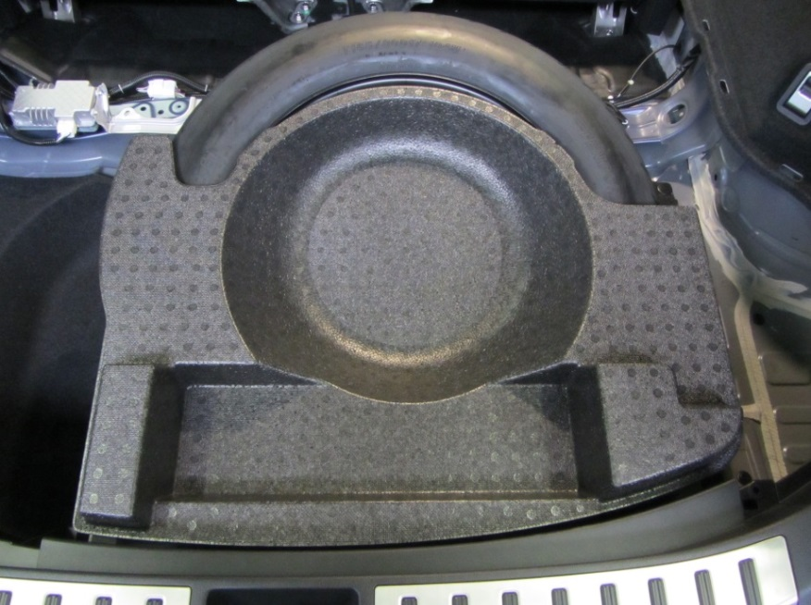
  - Remove the Styrofoam tray from the top of the spare tire (Fig. 1-1).
Fig. 1-1
  - Remove the deck floor box.
    - Fold the back of the rear seat forward.

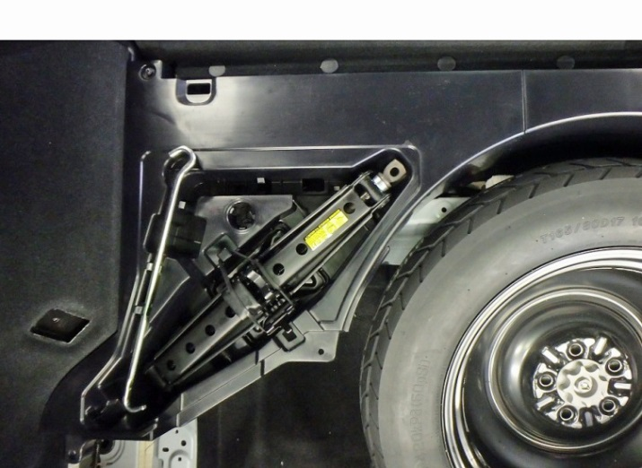
    - Remove the three clips (Fig. 1-2).
Fig. 1-2
Clip remover & #2 Philips screwdriver
    - Remove the screw ( Fig. 1-2).

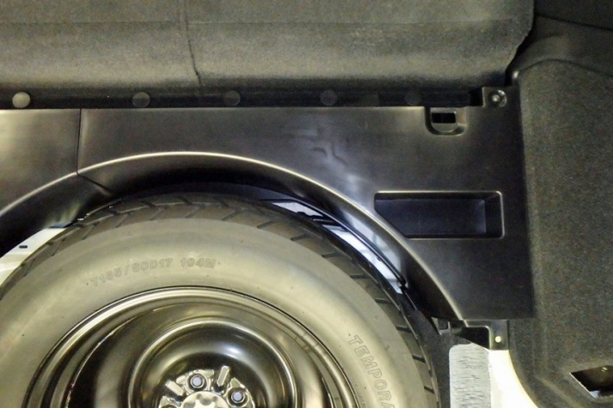
    - Remove the four clips (Fig. 1-3).
Fig. 1-3
Clip remover & #2 Philips screwdriver
    - Remove the screw ( Fig. 1-3).

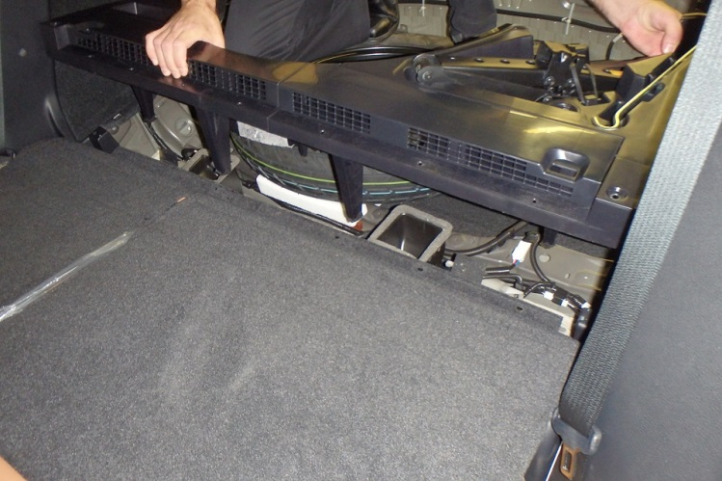
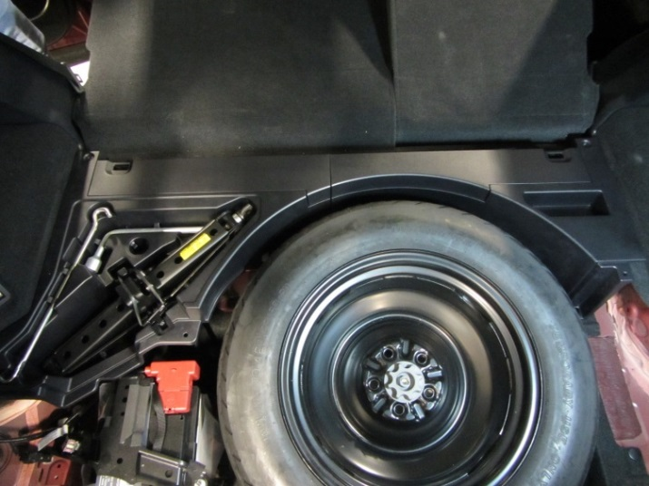
  - Pull the box to disengage the three clips attached to vehicle floor and remove the box assembly (Fig. 1-4 and Fig. 1-5).
Fig. 1-5
Fig. 1-4

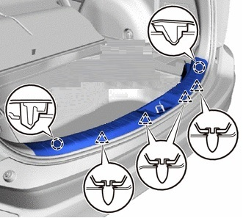
  - Detach the two claws ( ) and four clips () to remove the rear floor finish plate (Fig 1-6).
Fig. 1-6

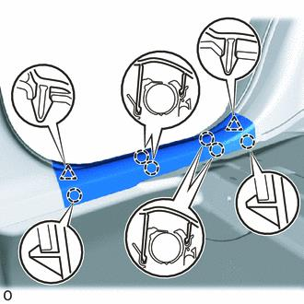
  - Detach the two clips () and six claws ( ); then remove the rear door scuff plate LH (Fig. 1-7).
Fig. 1-7

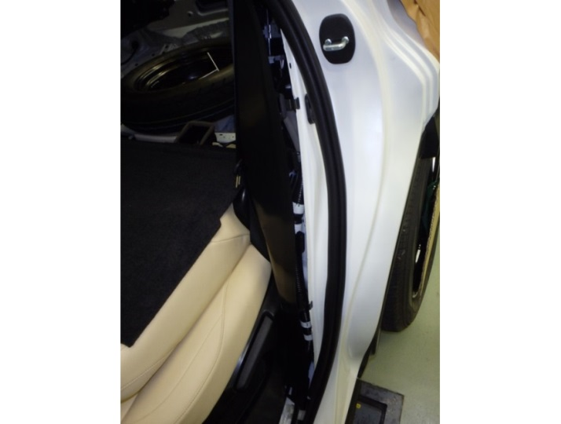
  - Partially remove the weather strip from the rear door LH in the wheel house area (Fig. 1-8).
Fig. 1-8

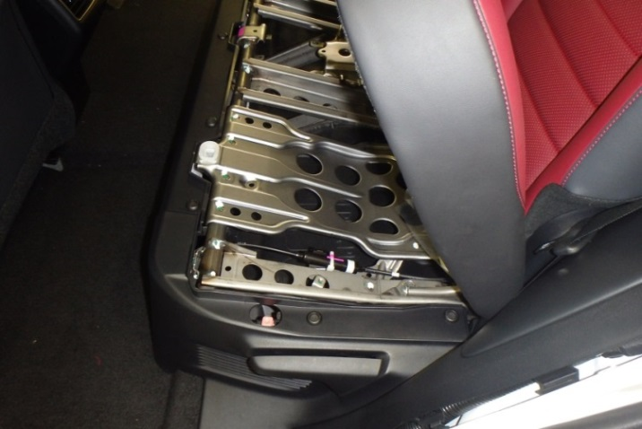
  - Remove the trim panel on the side of the rear seat LH to allow the removal of the deck trim side panel assembly LH (Fig. 1-9).
Fig. 1-9
    - Raise the LH seat back to the upright position.
    - Lift the rear seat up (Fig. 1-9).

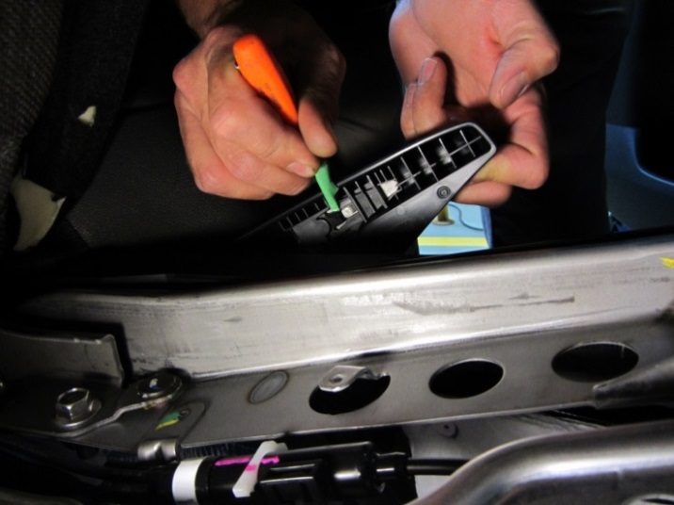
    - Manual Seat Only: Lift the reclining adjuster release handle LH to gain access to its retaining lock. Use a small screwdriver to lift the retaining lock and remove the handle (Fig. 1-10).
Fig. 1-10
Small flat screwdriver
HINT: Tape the screwdriver tip.

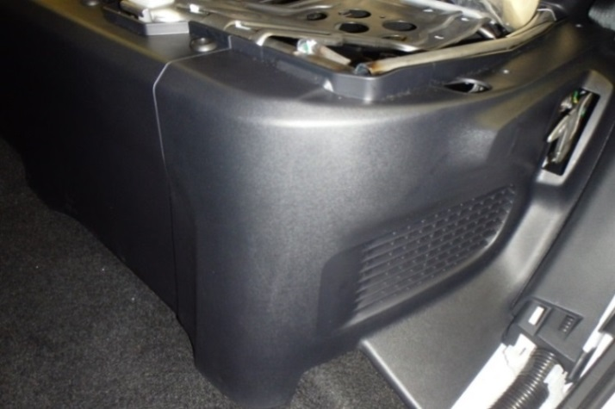
    - Remove the two push pins on the top of the side panel ( Fig. 1-11).
Fig. 1-11
Small flat screwdriver

    - Disengage the two clips in front of the side panel and remove the rear seat side panel LH (Fig. 1-11).

  - Detach the two clips () and six claws ( ); then remove the rear door scuff plate RH (Fig. 1-12).
Fig. 1-12

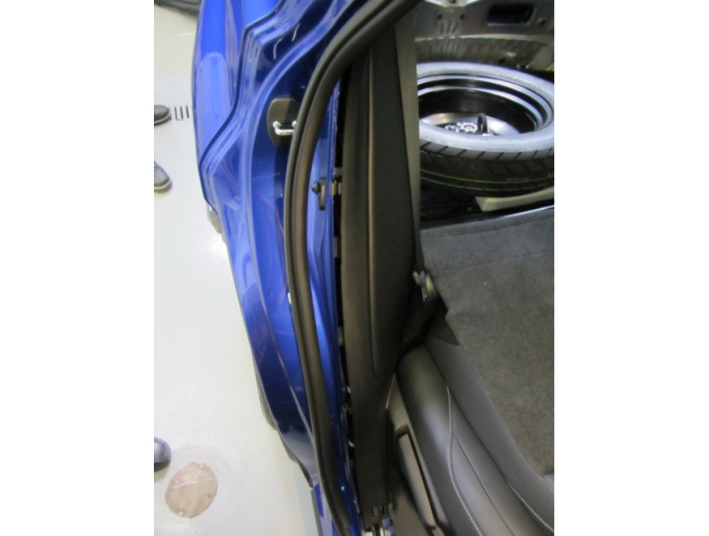
  - Partially remove the weather strip from the rear door RH in the wheel house area (Fig. 1-13).
Fig. 1-13

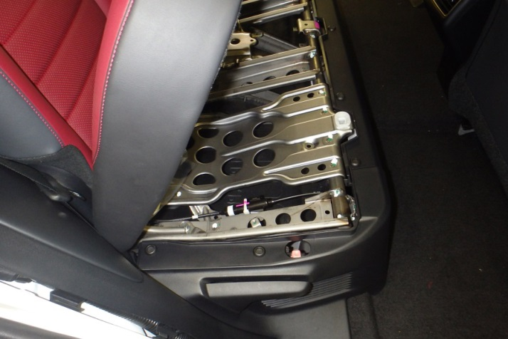
  - Remove the trim panel on the side of the rear seat RH to allow the removal of the deck trim side panel assembly RH (Fig. 1-14).
Fig. 1-14
    - Raise the RH seat back to the upright position.
    - Lift the rear seat up (Fig. 1-14).

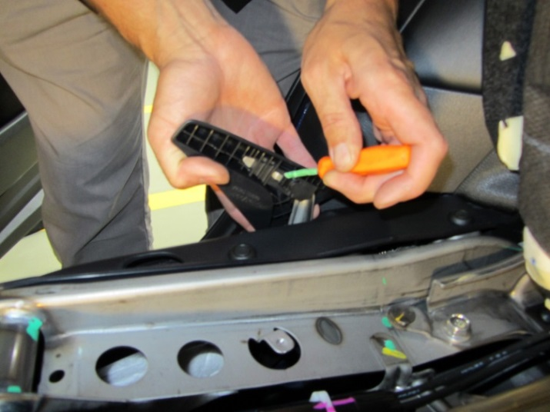
    - Manual Seat Only: Lift the reclining adjuster release handle RH to gain access to its retaining lock. Use a small screwdriver to lift the retaining lock and remove the handle (Fig. 1-15).
Fig. 1-15
Small flat screwdriver

HINT: Tape the screwdriver tip.

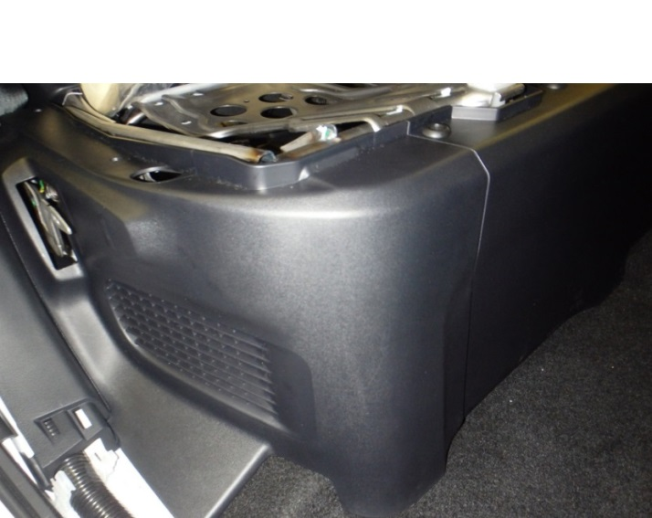
    - Remove the two push pins on the top of the side panel ( Fig. 1-16).
Fig. 1-16
Small flat screwdriver

    - Disengage the two clips in front of the side panel and remove the rear seat side panel RH (Fig. 1-16).

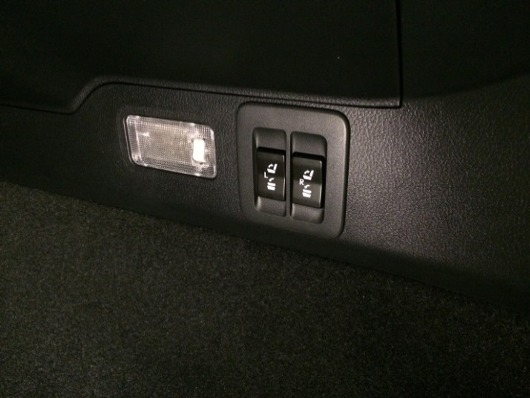
  - Use the switches in the RH deck trim side panel assembly to lower the LH and RH seat backs (Fig. 1-17).
Fig. 1-17
  - Move the power driver seat (if equipped) forward, just enough to access and remove the lower front seat belt bolt LH.

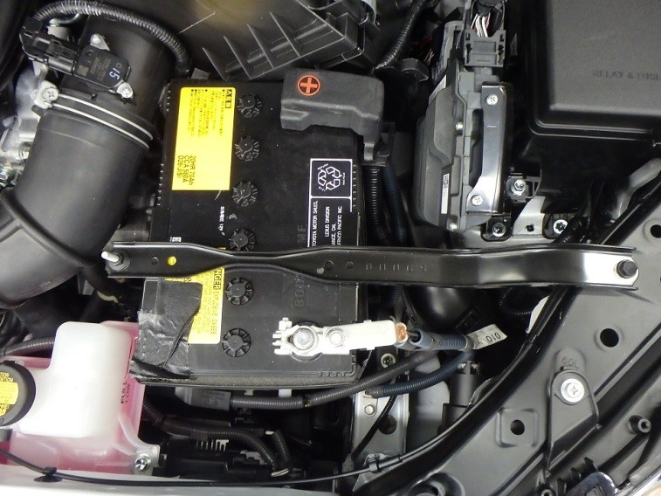
  - Use a 10 mm wrench to disconnect the negative (-) battery terminal from the battery and isolate the negative battery terminal (Fig. 1-18).
Fig. 1-18
10mm wrench or socket & ratchet

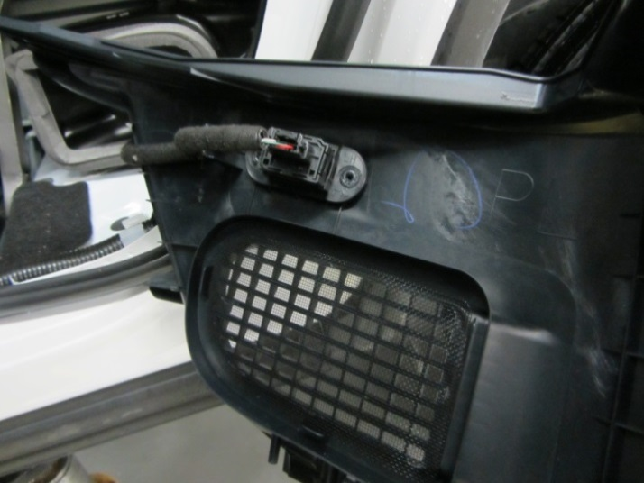
  - Power Seat Only: Disconnect the power seat switches and remove the clip from the seat side panel LH (Fig. 1-19).
Fig. 1-19

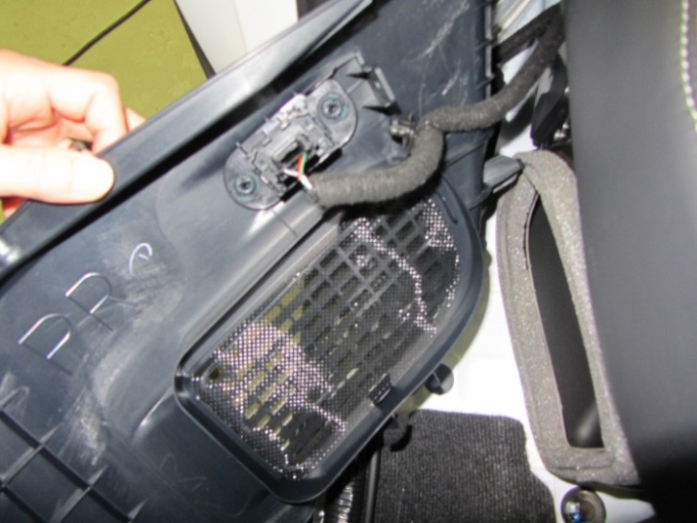
  - Power Seat Only: Disconnect the power seat switches and remove the clip from the seat side panel RH (Fig. 1-20).
Fig. 1-20

  - Remove the deck trim side panel assembly LH.
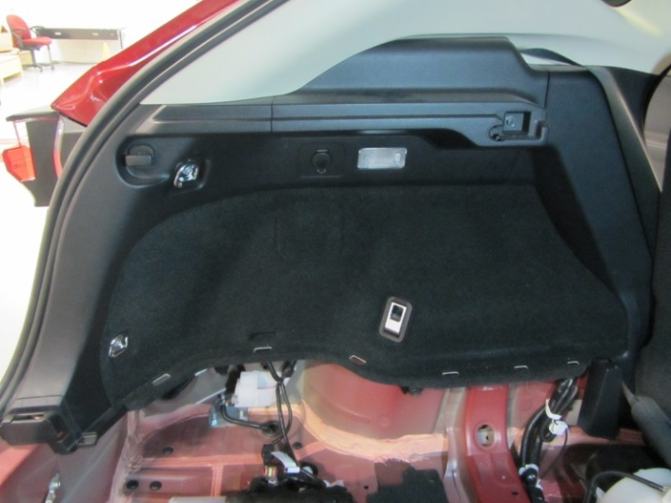
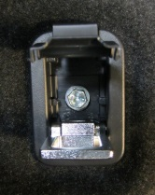
    - Open the tether anchor set bracket cover (Fig. 1-21).
Fig. 1-21
10mm socket, extension & ratchet; Phillips screwdriver
D-Ring (x2)
Bolt
Tie down Hook
    - Remove the bolt and tether anchor set bracket (Fig. 1-21 insert).
    - Remove the bolts and the two D-Rings (Fig. 1-21).
    - Push the tie down hook and turn it 90 degrees to have the squeezable tab on top, then press the tab and pull the hook to remove it (Fig. 1-21).
    - Remove the bolt that secures the upper trim sub-panel (Fig. 1-21).
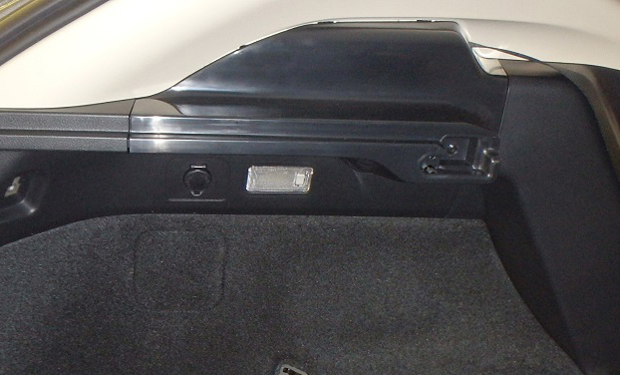
    - Pull the upper panel to disengage all eleven clips and remove the panel (Fig. 1-22).
Fig. 1-22

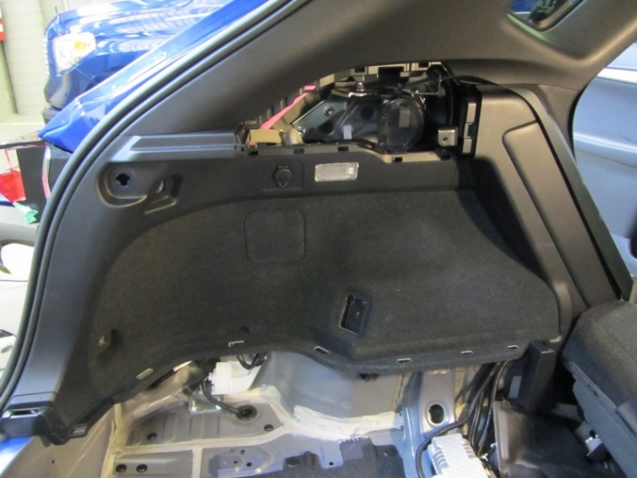
    - Disengage the eight clips to displace the deck trim side panel assembly LH (Fig. 1-23).
Fig. 1-23
    - Disconnect the electrical connectors for the cargo lamp and power outlet, and then remove the deck trim side panel assembly LH by pulling it rewards.

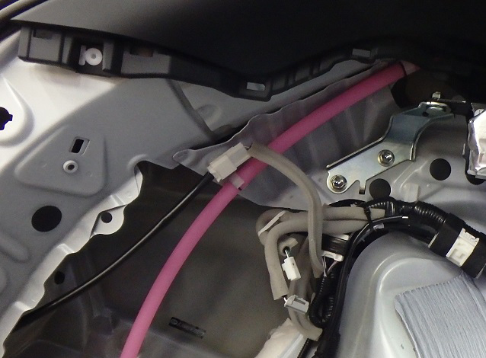
  - Disconnect the 4 pin in-line electrical connector to LH rear combination lamp assembly (Fig. 1-24).
Fig. 1-24

  - Remove the deck trim side panel assembly RH.
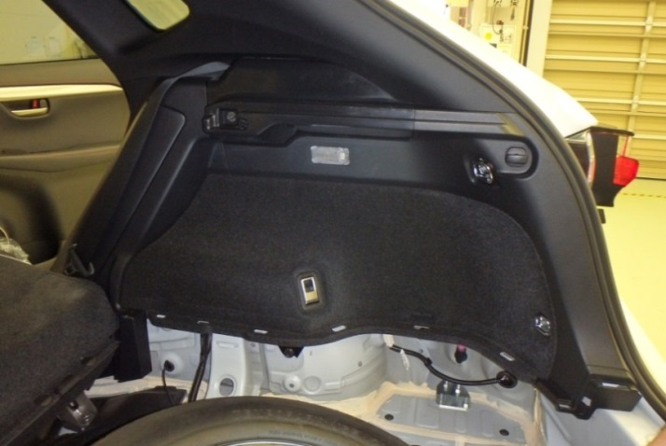
    - Open the tether anchor set bracket cover (Fig. 1-25).
Fig. 1-25
10mm socket, extension & ratchet; Phillips screwdriver
D-Ring (x2)
Bolt
Tie down Hook
    - Remove the bolt and tether anchor set bracket (Fig. 1-25 insert).
    - Remove the bolts and the two D-Rings (Fig. 1-25).
    - Push the tie down hook and turn it 90 degrees to have the squeezable tab on top, then press the tab and pull the hook to remove it (Fig. 1-25).
    - Remove the bolt that secures the upper trim sub-panel (Fig. 1-25).
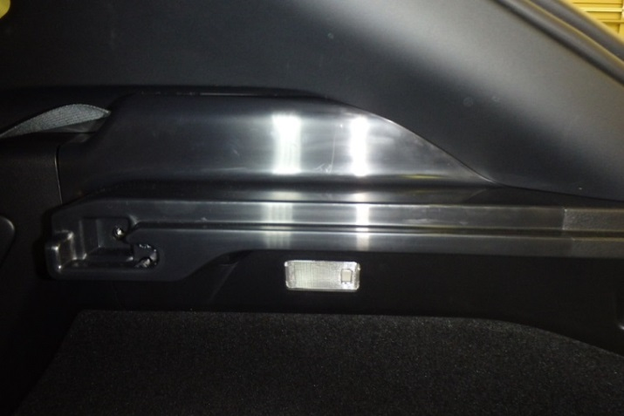
    - Pull the upper panel to disengage all eleven clips and remove the panel (Fig. 1-26).
Fig. 1-26

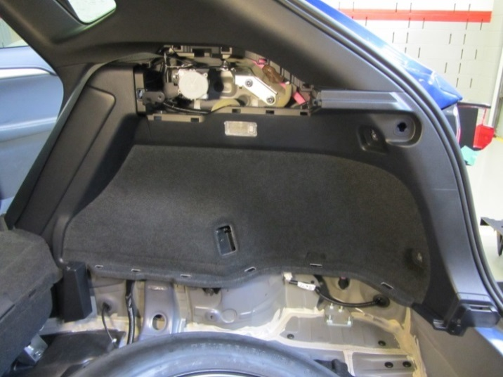
    - Disengage the nine clips to displace the deck trim side panel assembly RH (Fig. 1-27).
Fig. 1-27
  - Disconnect the electrical connectors for the cargo lamp and remove the deck trim side panel assembly RH by pulling it rewards.

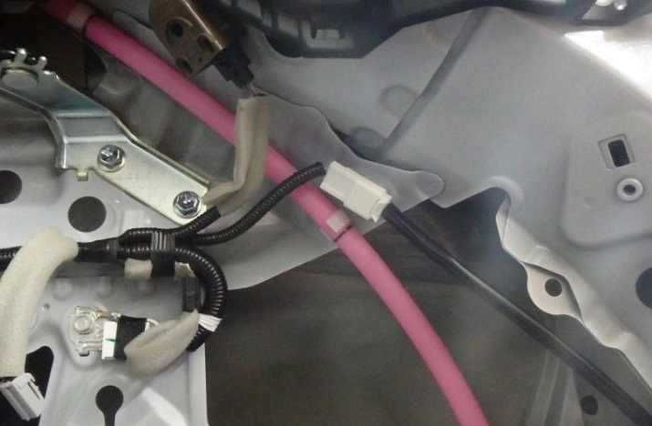
  - Disconnect the 4 pin in-line electrical connector to RH rear combination lamp assembly (Fig. 1-28).
Fig. 1-28

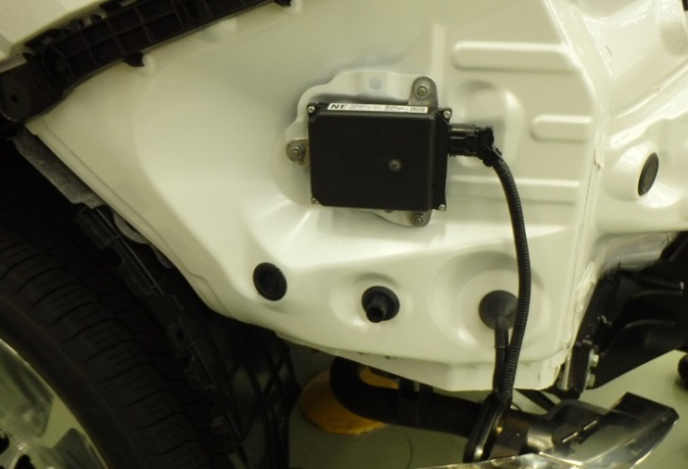
  - Remove and discard the trailer sub-wire harness pass through hole plug (Fig. 1-29).
Fig. 1-29

  - Remove the windshield wiper arms.
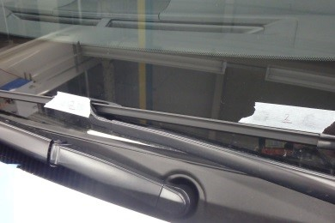
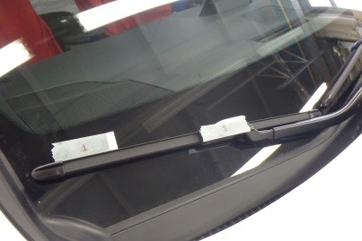
    - Use masking tape to mark the original position of the wipers on the windshield to facilitate the correct reassembly (Fig. 1-30 and Fig. 1-31).
Fig. 1-31
Fig. 1-30

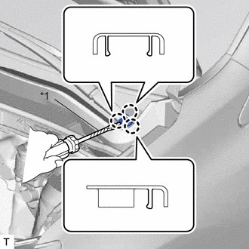
    - Use a screwdriver to detach the 3 claws and remove the windshield wiper arm cover ( Fig. 1-32). Repeat for the other side.
Fig. 1-32
Small flat screwdriver
HINT: Tape the screwdriver tip.

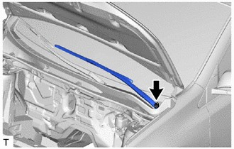
    - Remove the nut and the front wiper arm and blade assembly LH ( Fig. 1-33).
Fig. 1-33
14mm socket, ratchet & extension

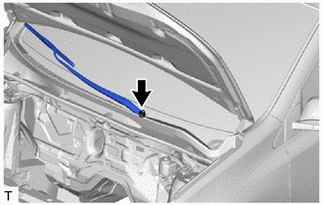
    - Remove the nut and the front wiper arm and blade assembly RH ( Fig. 1-34).
Fig. 1-34
14mm socket, ratchet & extension

  - Remove the front fender to cowl side seals.
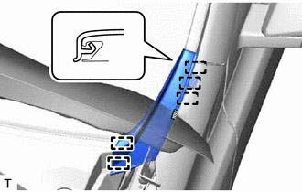
    - Detach the 5 claws and remove the double-sided tape to remove the front fender to cowl side seal LH (Fig. 1-35).
Fig. 1-35
    - Repeat the process on the front fender to cowl side seal RH.

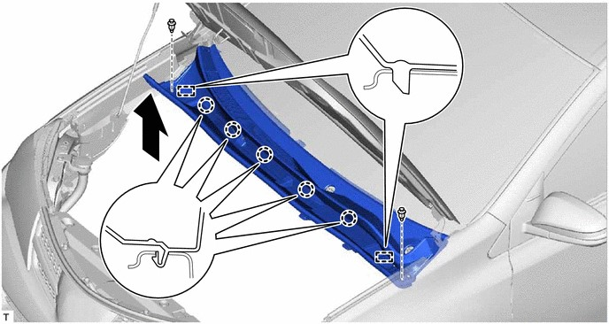
  - Remove the cowl top ventilator louver sub-assembly.
Fig. 1-36
Small flat screwdriver, clip remover
    - Push on the center to remove the 2 push pins (Fig. 1-36).
    - Detach the 5 claws ( ) and 2 guides (Fig. 1-36).

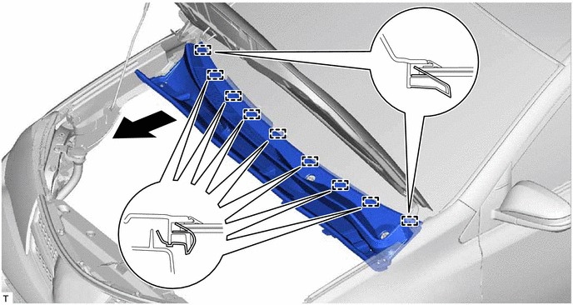
    - Detach the 9 guides and pull out the cowl top ventilator louver sub-assembly ( Fig. 1-37).
Fig. 1-37
  - Remove the windshield wiper motor and link assembly.
NOTE: Be careful not to damage the windshield when removing the windshield wiper motor and link assembly.
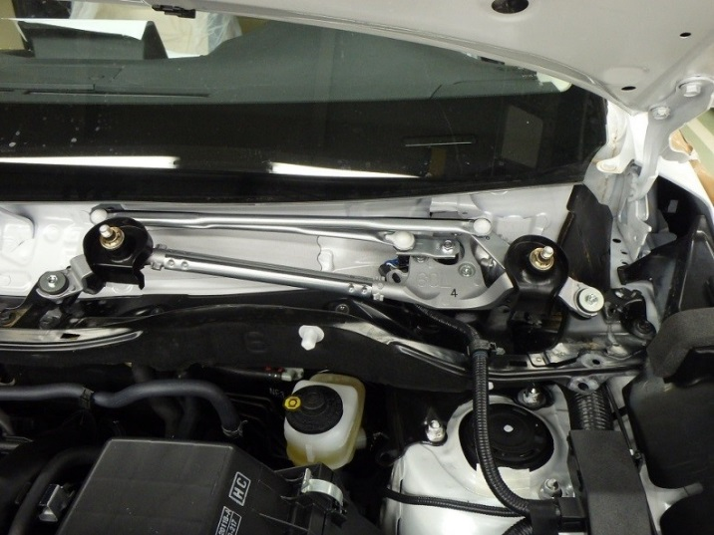
    - Remove the 2 bolts ( Fig. 1-38).
Fig. 1-38
10mm socket, extension & ratchet

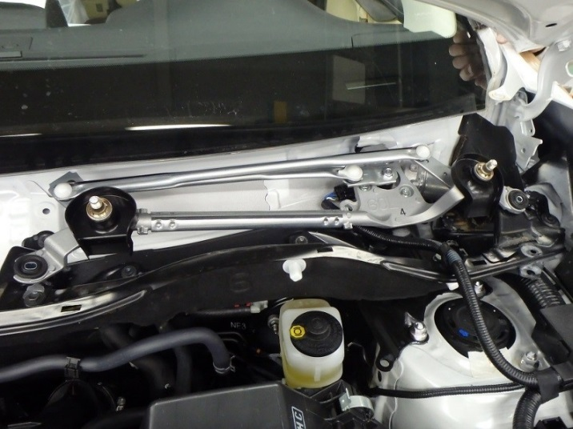
    - Slide the windshield wiper motor and link assembly towards the passenger side as shown by the arrow in Fig. 1-39 to disengage the assembly from the vehicle.
Fig. 1-39
Wire clamp (x2)
Grommet
Electrical connector
    - Disconnect the electrical connector and detach the two wire clamps (Fig. 1-39) to remove wiper motor and link assembly.

  - Remove the cover top panel outer sub-assembly.
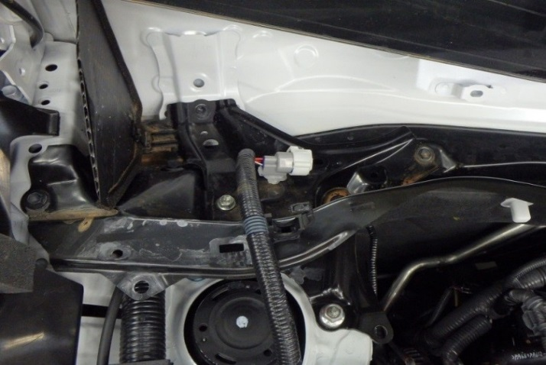
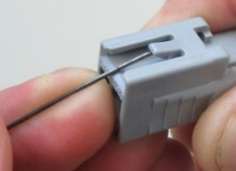
    - Disconnect the grey connector (if connected, Fig. 1-40).
Fig. 1-40
Small pick tool, small flat screwdriver
Clamp
Grey connector
    - Use a small pick tool to disengage the grey connector housing from the white clip without removing the clip from the metal cowl (Fig. 1-40).
HINT: The picture insert (Fig. 1-40) shows how to lift the connector lock to disengage it from the clip.
    - Disengage the vehicle wire from the black clamp (Fig 1-40).

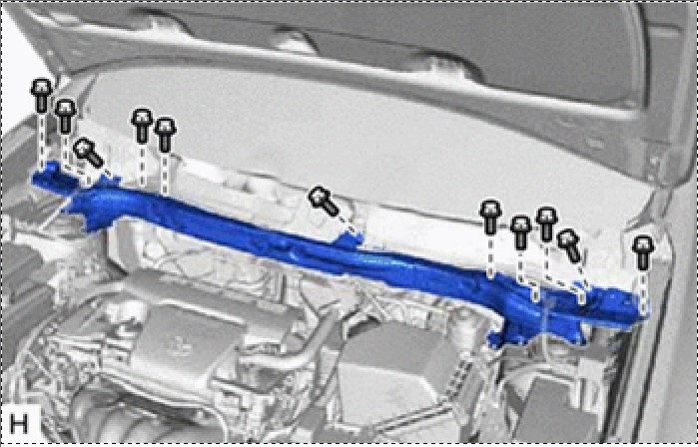
    - For vehicles without a strut tower brace, remove the 11 bolts and the cowl top panel outer sub-assembly (Fig. 1-41).
Fig. 1-41
12mm & 10mm sockets, ratchet & extension

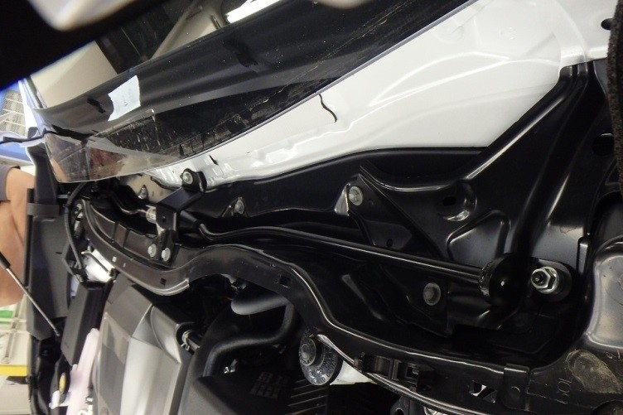
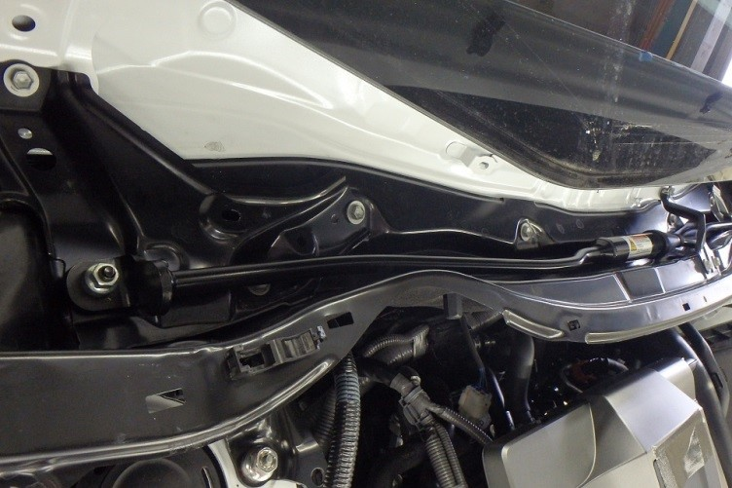
    - If the vehicle is equipped with a strut tower brace, remove an additional 2 nuts ( Fig. 1-42 and Fig. 1-43) and then the cowl top panel outer sub-assembly and brace together.
Fig. 1-43
12mm & 10mm sockets, ratchet & extension
Fig. 1-42
12mm & 10mm sockets, ratchet & extension
NOTE: Do not remove the strut brace separately.

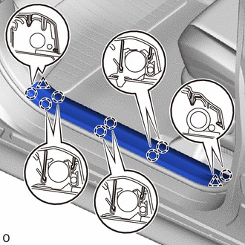
  - Detach the 8 claws ( ) and 2 clips ( ) and remove the front door inside scuff plate LH (Fig. 1-44).
Fig. 1-44

  - Remove the cowl side trim board LH.
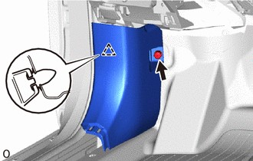
    - Remove the nut ( Fig. 1-45).
Fig. 1-45
    - Detach the clip and remove the cowl side trim board LH (Fig. 1-45).

  - Remove lower center pillar garnish LH.
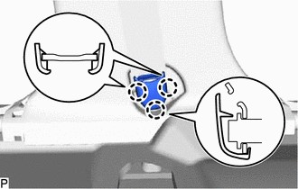
    - Detach the 3 claws to remove the outer lap belt anchor cover ( Fig. 1-46).
Fig. 1-46
Screwdriver

HINT: Tape the screwdriver tip.

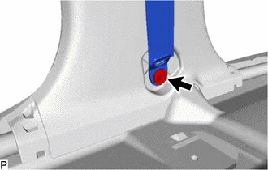
    - Remove the bolt and disconnect the floor anchor of the front seat outer belt assembly LH ( Fig. 1-47).
Fig. 1-47
14mm socket & ratchet

    - Partially remove the weather strip from the front and rear door LH openings in the center pillar panel area (Fig. 1-48).
Fig. 1-48

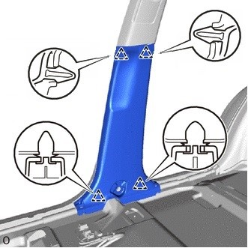
    - Disengage the 4 clips and remove the center pillar lower garnish LH (Fig. 1-49).
Fig. 1-49

Install the Trailer Power Wire.
  - Install the B+ terminal from the trailer power wire to the positive battery cable/terminal.
    - Locate the provided trailer power wire harness. Remove the 15A fuse from the fuse holder. It will be reinstalled after the installation is complete.
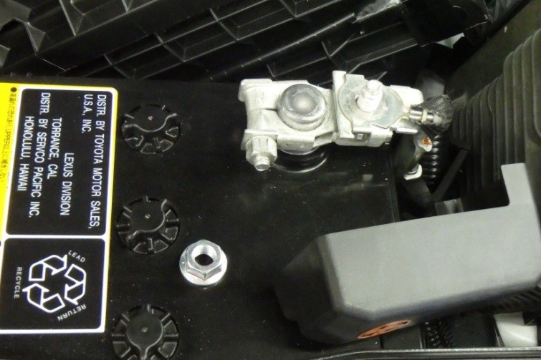
    - Locate and uncover the B+ battery post (Fig. 2-1).
Fig. 2-1
12mm socket, extension & ratchet
B+ battery post
M8 nut (removed)
    - Remove the M8 nut from the positive battery cable (Fig. 2-1).

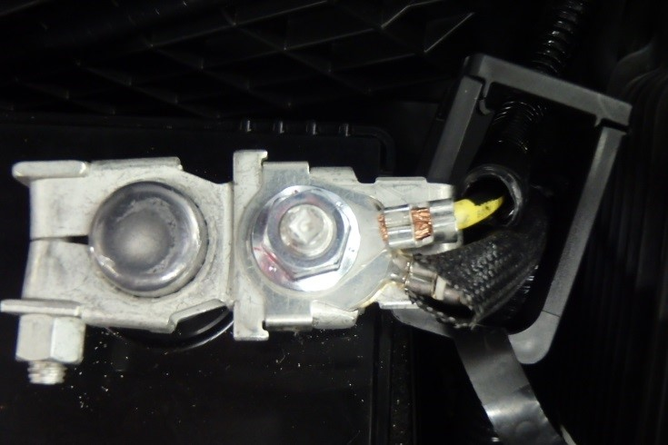
    - Route the trailer power wire inside the B+ cover clamp or along the positive battery cable and attach the terminal to the battery terminal (Fig. 2-2).
Fig. 2-2
12mm socket, extension & torque wrench
B+ trailer power wire terminal
NOTE: Make sure to position the ring terminal so that the protective cover can be reinstalled over the post.
    - Reinstall the M8 wire nut and torque it to 5.4 N•m (48 lbf•in).
Torque: 5.4 N•m (48 lbf•in)

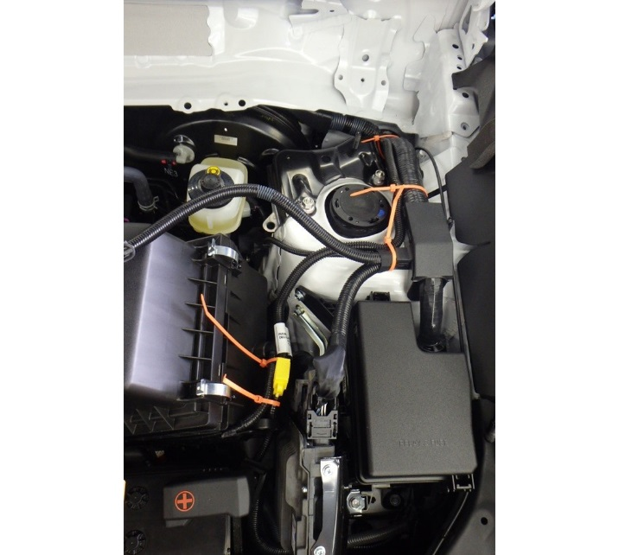
  - Starting from the B+ battery terminal, route the trailer power wire along the vehicle wire harness in the underhood compartment (Fig. 2-3). Follow the vehicle wire harness towards and along the LH fender and secure the trailer power wire with wire ties.
Fig. 2-3
1
2
5
4
3
NOTE: Do not secure the trailer power wire or any wire ties to the hood cable. The hood cable must remain unbound for proper operation.
NOTE: Orange wire ties are used for illustration purposes. The actual wire ties in the kit are black.
  - Route the trailer power wire through the dash grommet.
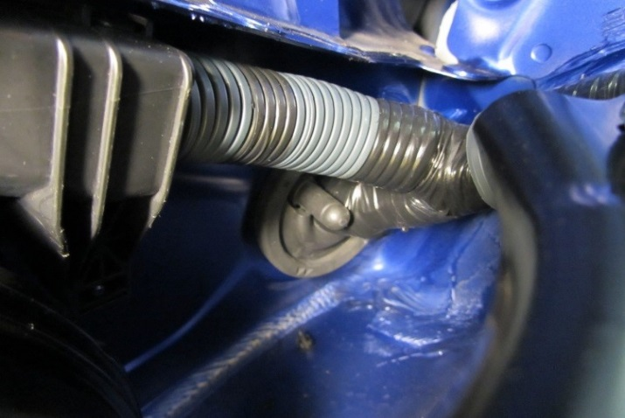
    - Locate the grommet near the brake booster and suspension on the driver side of the vehicle. Locate the grommet nipple to pass the wire through (Fig. 2-4).
Fig. 2-4
Grommet nipple

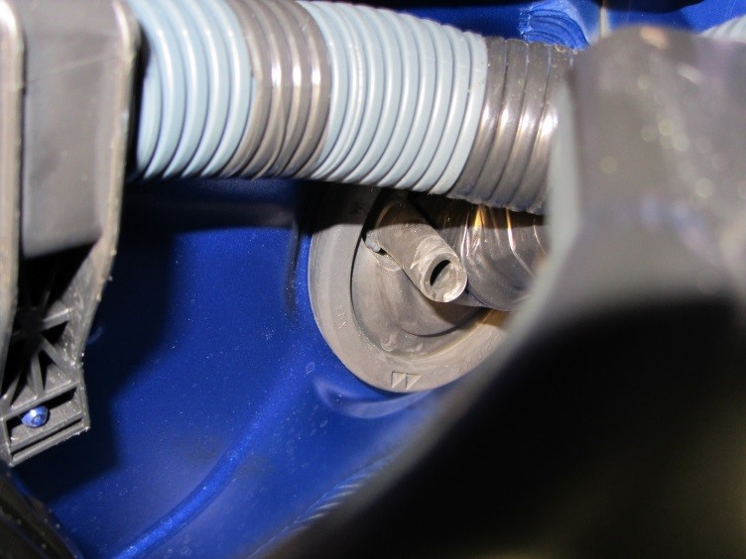
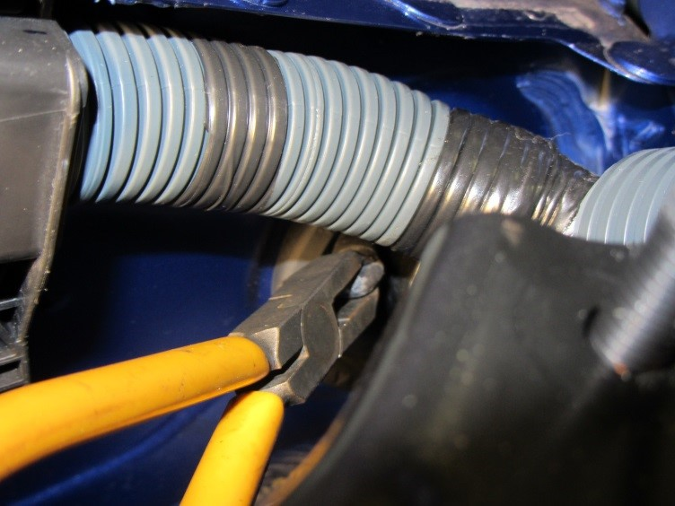
    - Cut the tip of the grommet nipple (Fig. 2-5 and Fig. 2-6).
Fig. 2-6
Grommet nipple, cut
Fig. 2-5
Side cutters

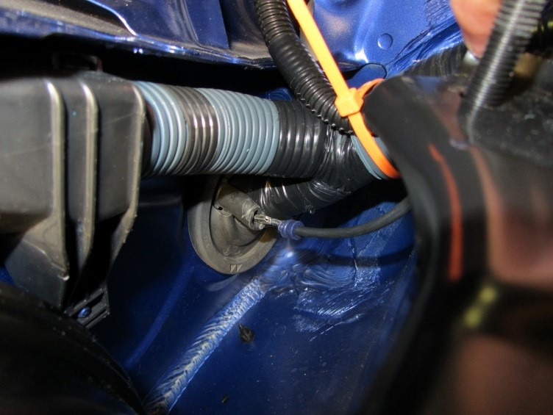
    - Push the trailer power wire through the bulkhead grommet into the vehicle interior (Fig. 2-7). Move the carpet surrounding the bulkhead grommet away to facilitate the initial wire pass through.
Fig. 2-7
HINT: Add a small amount of dielectric grease into the terminal crimping and cable seal of the power wire to facilitate the initial wire pass-through. Wipe any remaining grease off once the power wire comes into the vehicle interior.

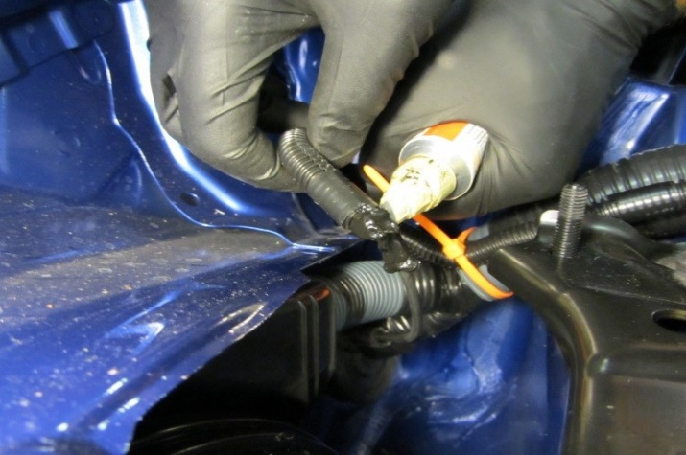
    - Continue pushing the trailer power wire into the vehicle interior until about 50 mm of power wire remains between its convoluted tube and the tip of the grommet nipple (Fig. 2-8).
Fig. 2-8
~50mm of exposed wire insulation
    - Add Wurth Black Silicone Special 250 to the 50mm of exposed wire insulation (Fig. 2-8).

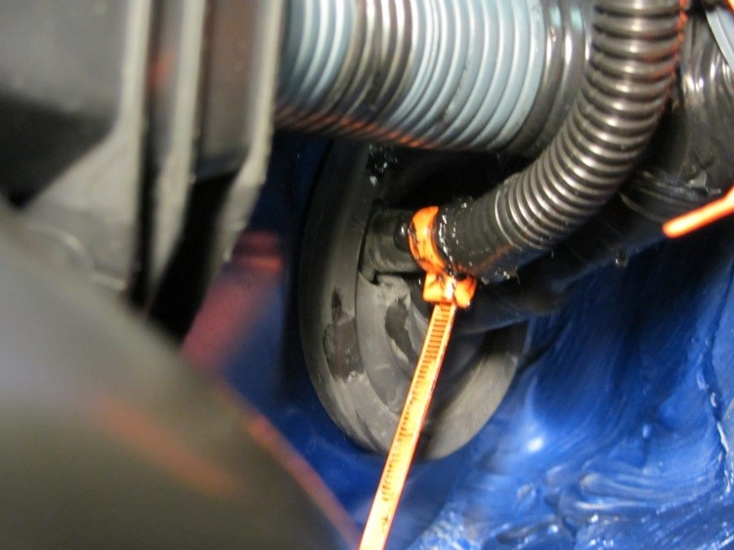
    - Push the excess trailer power wire into the vehicle interior until the convoluted tube meets the grommet nipple and secure the wire with a wire tie over the grommet nipple (Fig. 2-9).
Fig. 2-9
6

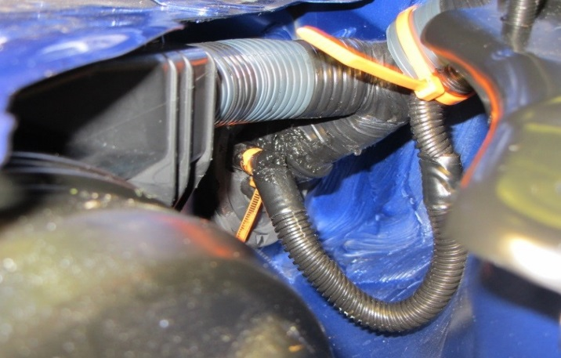
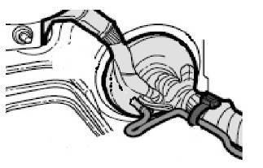
    - Route the power wire with a U-Shape loop (Fig. 2-10 and Fig. 2-11) right before the grommet to prevent water intrusion to vehicle interior.
Fig. 2-11
Fig. 2-10
    - Cut the excess off the wire ties used in the under hood compartment.

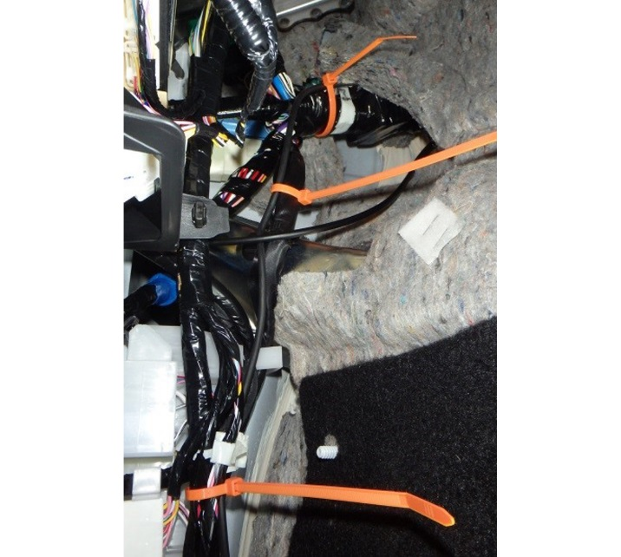
  - Route the trailer power wire along the vehicle wire harness in the vehicle interior and secure the trailer power wire every 150mm (6 inches) (Fig. 2-12).
Fig. 2-12
9
8
7

NOTE: Do not secure the trailer power wire or any wire ties to the hood cable. The hood cable must remain unbound for proper operation.

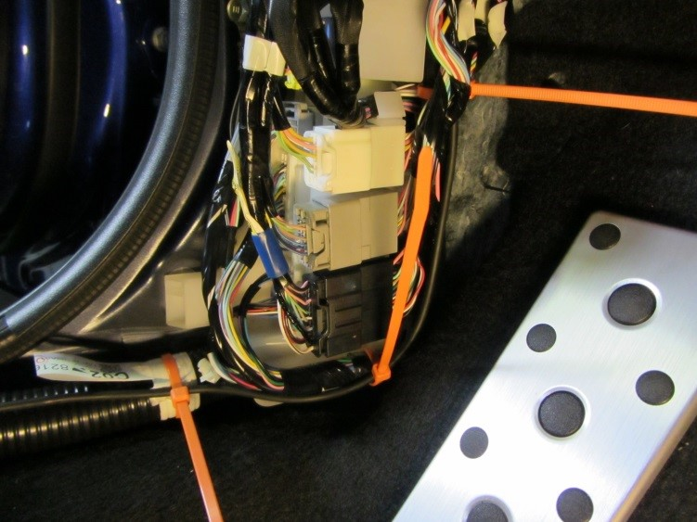
  - Continue to route the trailer power wire along the vehicle wire harness in the vehicle interior and secure the trailer power wire every 150mm (6 inches) (Fig. 2-13).
Fig. 2-13
10
11

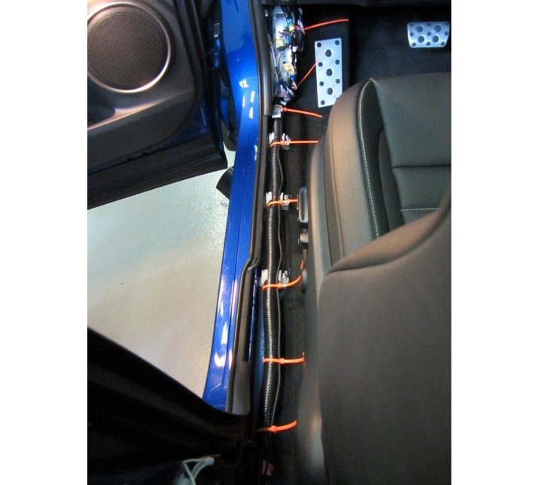
  - Continue to route the trailer power wire along the vehicle wire harness in the driver’s door threshold area (Fig. 2-14).
Fig. 2-14
13
14
12
15
16

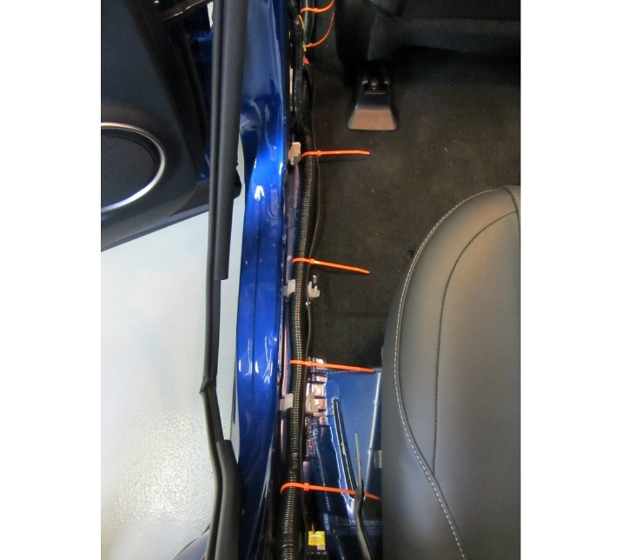
  - Continue to route the trailer power wire along the vehicle wire harness in the LH B-pillar area (Fig. 2-15).
Fig. 2-15
18
17
19
20

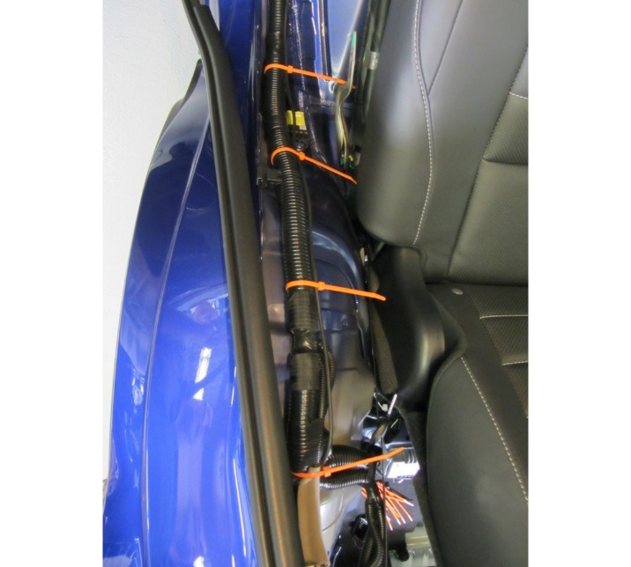
  - Continue to route the trailer power wire along the vehicle wire harness in the LH rear door threshold area (Fig. 2-16).
Fig. 2-16
21
22
23

  - Assemble the power wire connector.
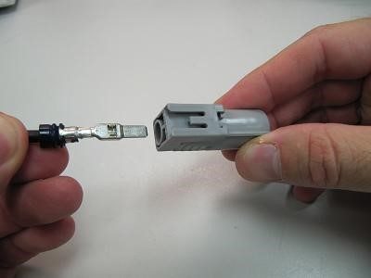
    - Insert the wire terminal into the connector housing (Fig. 2-17). Make sure the terminal is fully inserted.
Fig. 2-17

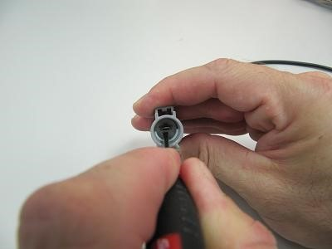
    - Push the white tab (terminal secondary lock) to lock the wire terminal into position (Fig. 2-18).
Fig. 2-18
Small flat screwdriver

Install the Trailer Module Harness.
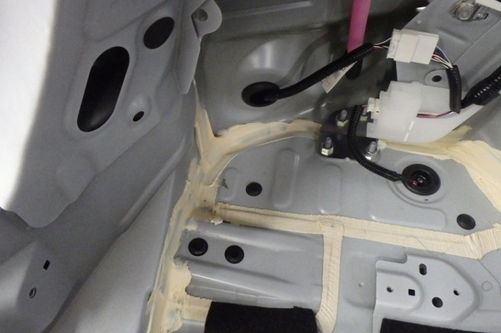
  - Locate the mounting surfaces to install the trailer wire harness module nearby the LH wheel house area (Fig. 3-1).
Fig. 3-1

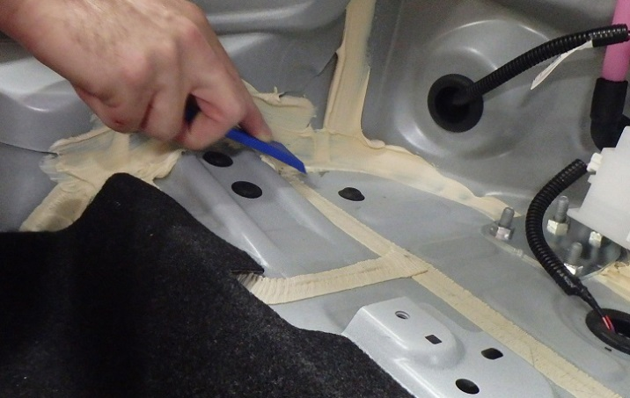
  - Scrape any body sealer that may be on the mounting surfaces (if necessary) as shown in Fig. 3-2 and clean the surfaces with VDC approved cleaner.
Fig. 3-2
Plastic scraper

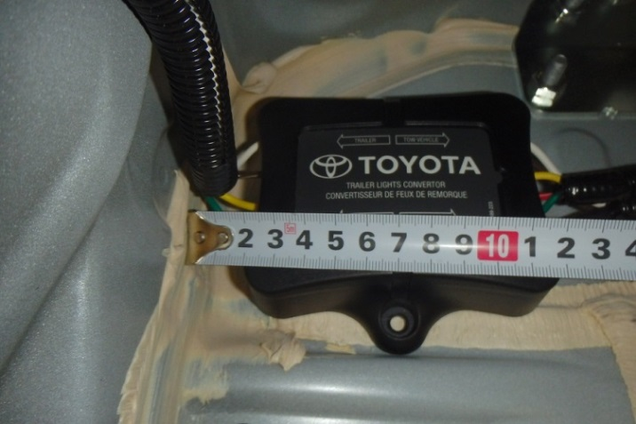
  - Determine the location of the trailer wire harness module following the dimensions below as reference (Fig. 3-3).
Fig. 3-3
Module tab
Body reinforcement
    - Approximately 20 mm away from the rear body panel.
    - Place the module side tab against the body reinforcement.
  - Peel off the double-sided tape backing strips.
  - Apply pressure and secure the module to the vehicle (Fig. 3-3).

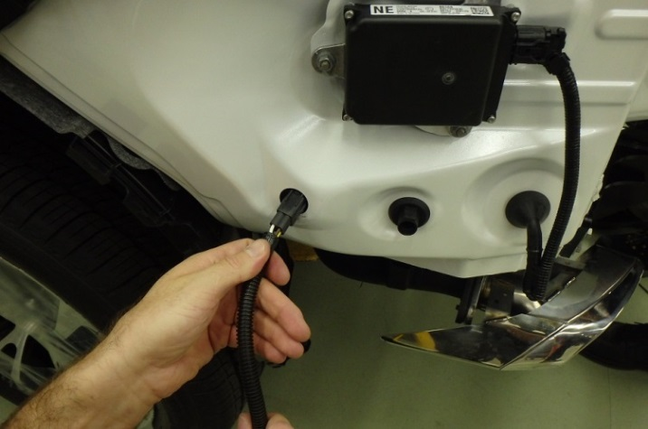
  - Pass the trailer sub-wire harness through the hole in the body (Fig. 3-4).
Fig. 3-4

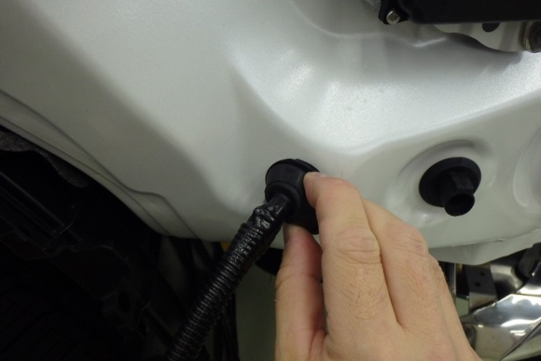
  - Insert the sub-wire grommet into the body hole (Fig. 3-5).
Fig. 3-5

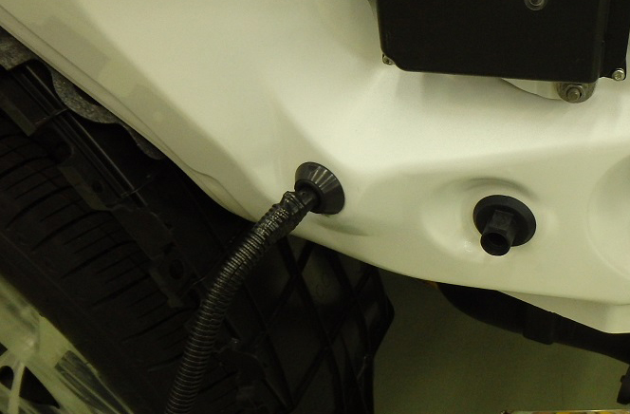
  - Make sure the grommet is fully seated to vehicle body hole (Fig. 3-6).
Fig. 3-6

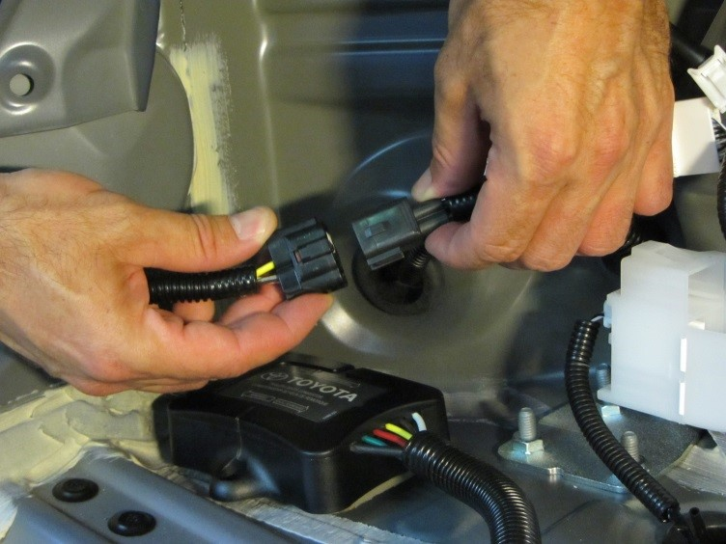
  - Connect the 4 pin in-line connector between the trailer sub-wire and module harnesses (Fig. 3-7).
Fig. 3-7
NOTE: Make sure the connectors are fully engaged.

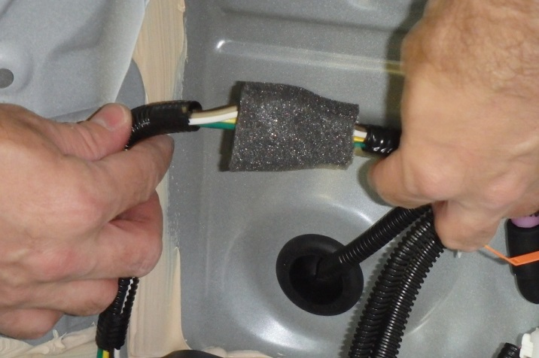
  - Wrap the 4 pin in-line connector with a piece of foam tape (Fig. 3-8).
Fig. 3-8

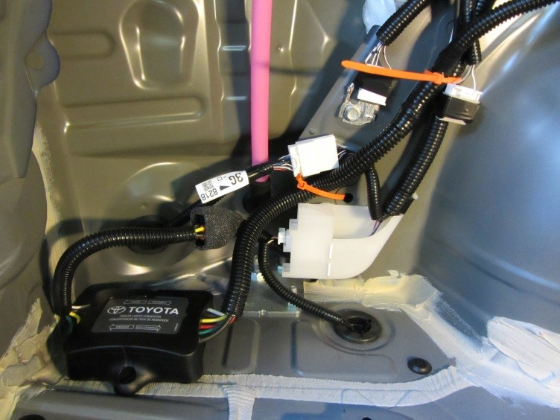
  - Start routing and securing the trailer module harness in the rear wheel house LH area (Fig. 3-9).
Fig. 3-9
24
25

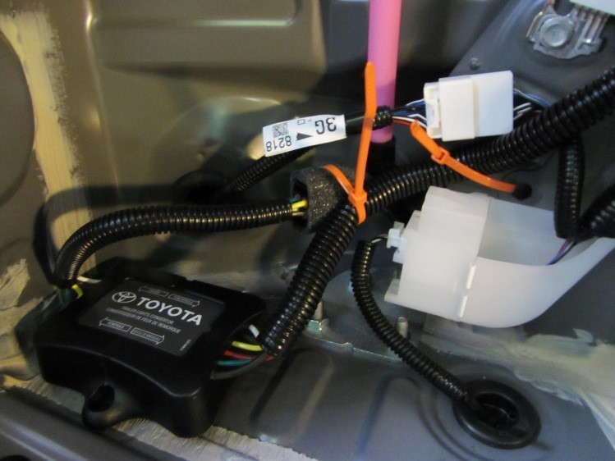
Fig. 3-10
26
  - Secure the 4 pin in-line connector between the trailer sub-wire and module harnesses to the wire with a wire tie (Fig. 3-10).

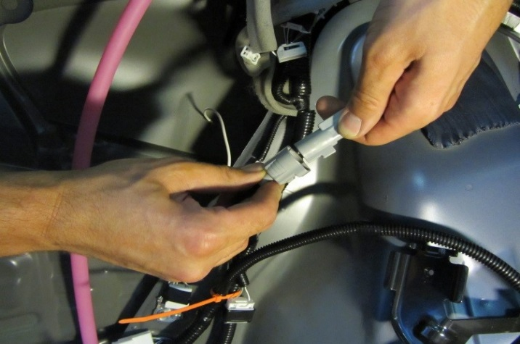
  - Connect the 1 Pin in-line connector between the trailer power wire and module harnesses (Fig. 3-11).
Fig. 3-11

NOTE: Make sure the connectors are fully engaged.

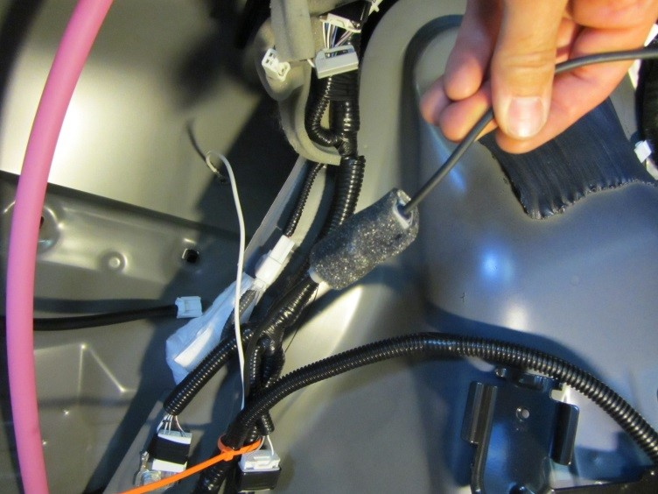
  - Wrap the 1 Pin in-line connector with a piece of foam tape (Fig. 3-12).
Fig. 3-12

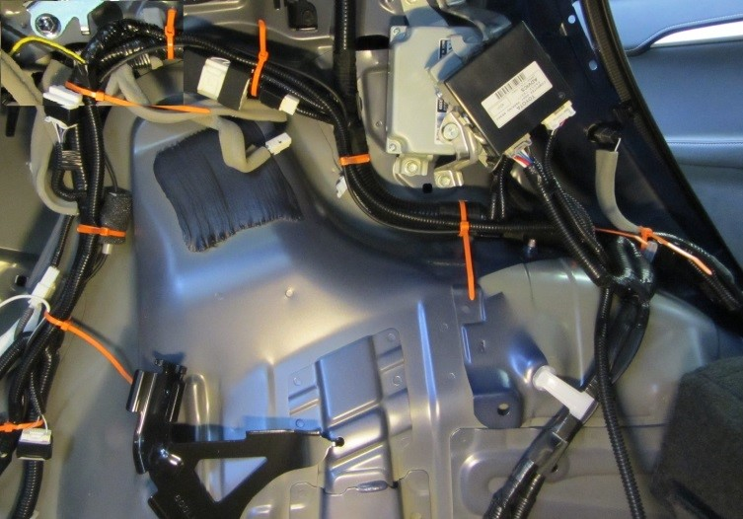
  - Continue routing and securing the trailer module harness along the vehicle wire harness (Fig. 3-13).
Fig. 3-13
27
28
29
30
31
32
33
34

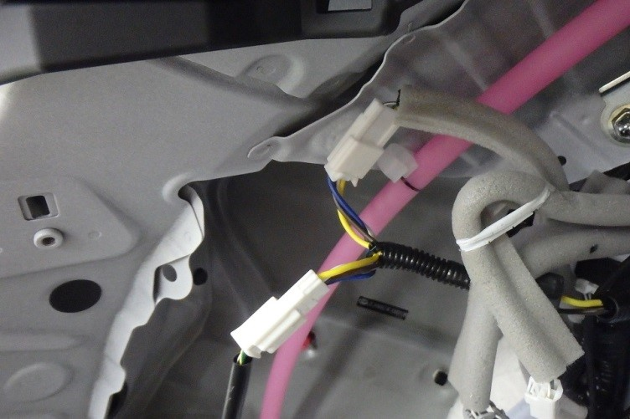
  - Connect the trailer module harness (T-type connection with yellow, brown, blue and white wires) between the rear combination lamp assembly LH pigtail and the vehicle wire harness (Fig. 3-14).
Fig. 3-14

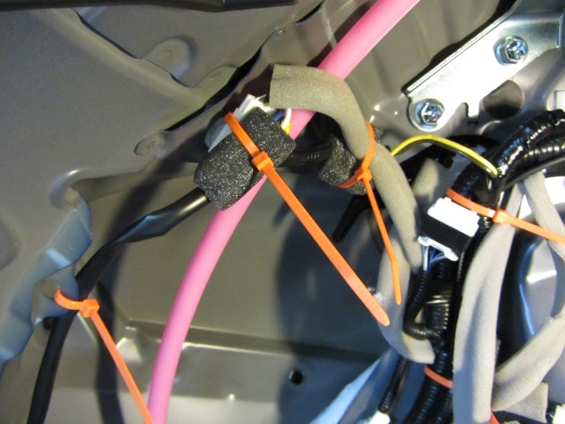
  - Wrap the in-line connector and splice joint with a piece of foam tape, then secure the branch to the rear combination lamp assembly LH (Fig. 3-15).
Fig. 3-15
36
35
37

  - Attach the trailer wire ground terminal to the vehicle ground attachment.
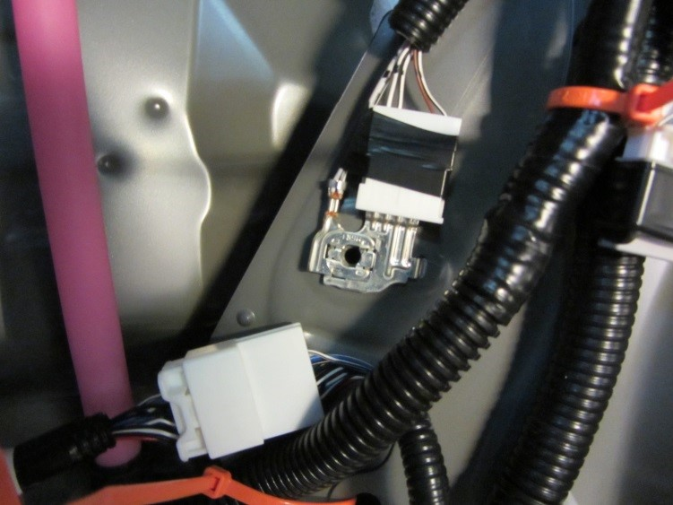
    - Use a 10mm socket to remove the ground bolt (Fig. 3-16).
Fig. 3-16
10mm socket, ratchet & ratchet

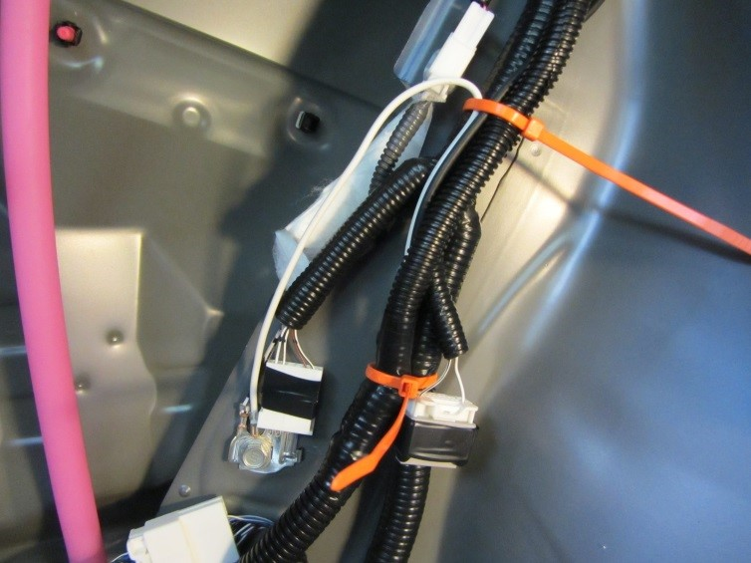
    - Attach the trailer white wire with ring terminal on top of the vehicle ground terminal (Fig. 3-17).
Fig. 3-17
10mm socket, ratchet & torque wrench
    - Reinstall the bolt and tighten it to 8.4 N•m (74 lbf•in).
Torque: 8.4 N•m (74 lbf•in)
NOTE: Make sure to reinstall all existing ground wires/terminals.

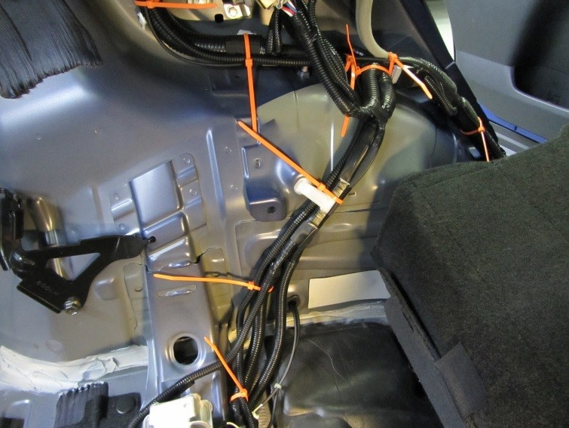
  - Route and secure the trailer module harness along the vehicle wire harness and towards the RH rear combination lamp assembly (Fig. 3-18).
39
38
40
41
Fig. 3-18

Front of vehicle

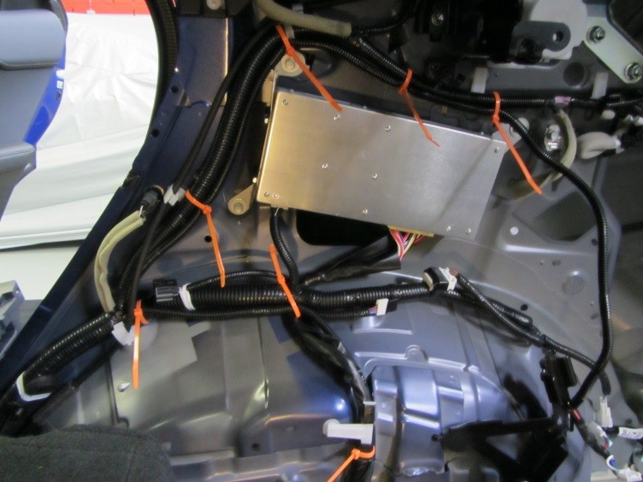
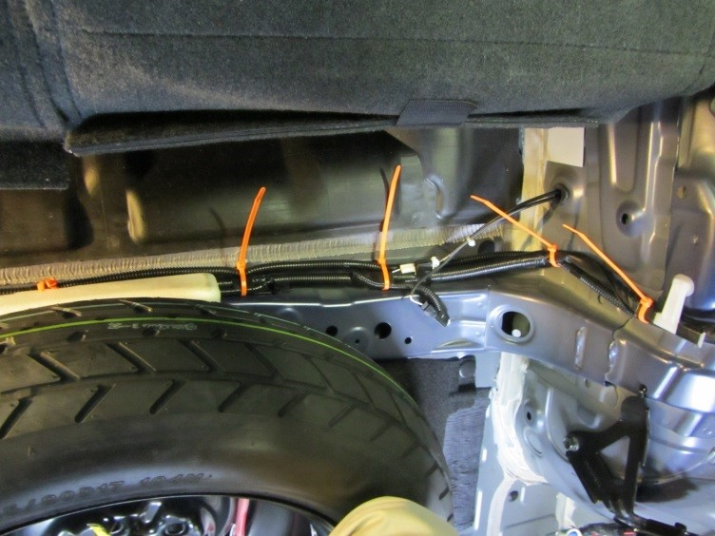
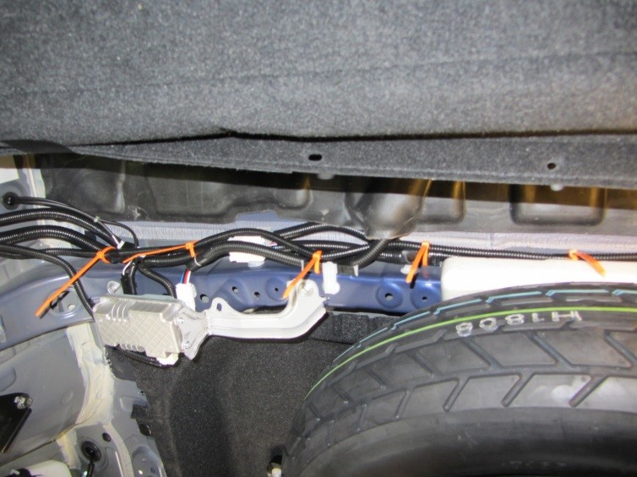
  - Continue to route and secure the trailer wire harness along the vehicle wire harness and towards the RH rear combination lamp assembly (Fig. 3-19 to Fig. 3-21).
52
Fig. 3-21
50
51
53
54
55
48
Fig. 3-20
46
47
Front of vehicle

49
42
Fig. 3-19
Front of vehicle

43
44
45

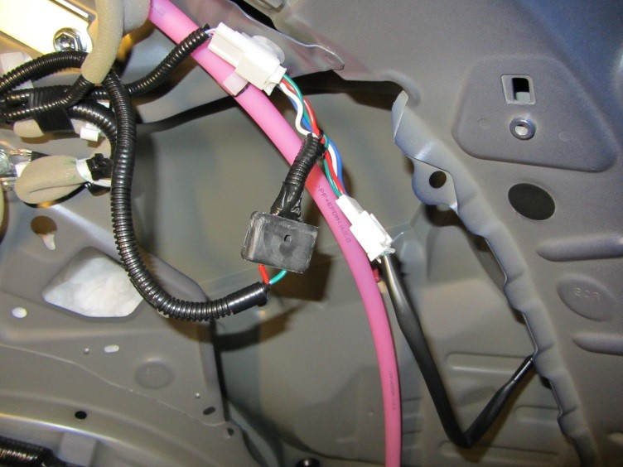
  - Connect the trailer module harness (T-type connection with red, green, blue and white wires) between the rear combination lamp assembly RH pigtail and the vehicle wire harness (Fig. 3-22).
Fig. 3-22

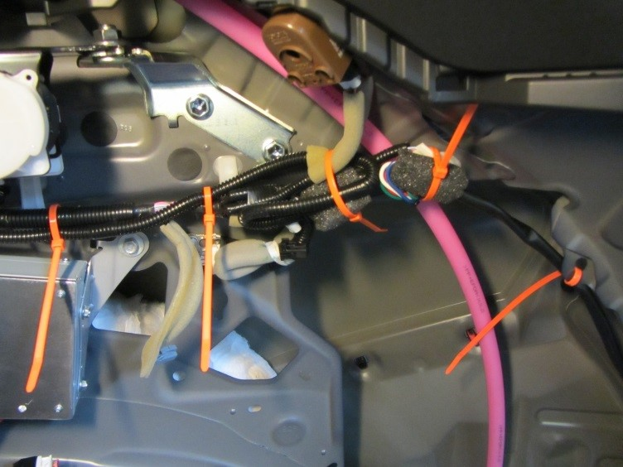
  - Wrap the in-line connector and splice joint with a piece of foam tape, then secure the branch to the rear combination lamp assembly RH (Fig. 3-23).
Fig. 3-23
57
56
58
59
  - Cut the excess off the wire ties used in the vehicle interior.

Install the Trailer Sub-Wire Harness.
NOTE: Install the tow hitch before proceeding with next steps (PLEASE REFER TO THE TOW HITCH INSTALLATION INSTRUCTIONS). Do not reinstall the rear bumper fascia until completing the trailer sub-wire harness installation.
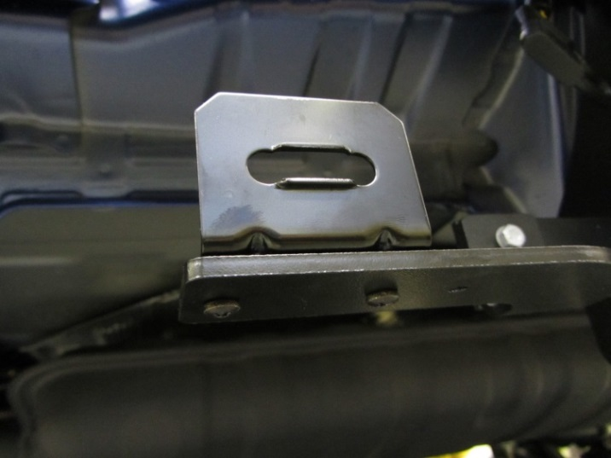
  - Use two sets of provided screws and nuts/washers to attach the L-shaped bracket for the trailer connector into the hitch bracket (Fig. 4-1).
Fig. 4-1
10mm socket & Phillips screwdriver

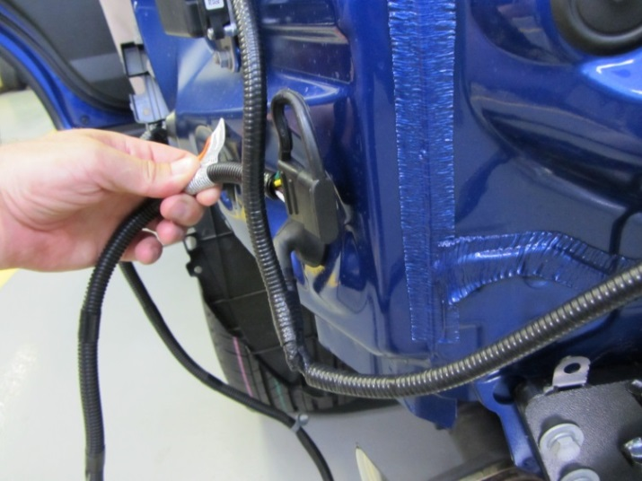
  - Pass the trailer sub-wire harness inside the vehicle wire harness for the blind spot monitoring system LH (if equipped) (Fig. 4-2). For vehicles without the blind spot monitoring system, route the harness in the same manner.
Fig. 4-2
  - Route the trailer sub-wire harness along the top of the hitch crossbar towards the passenger side.

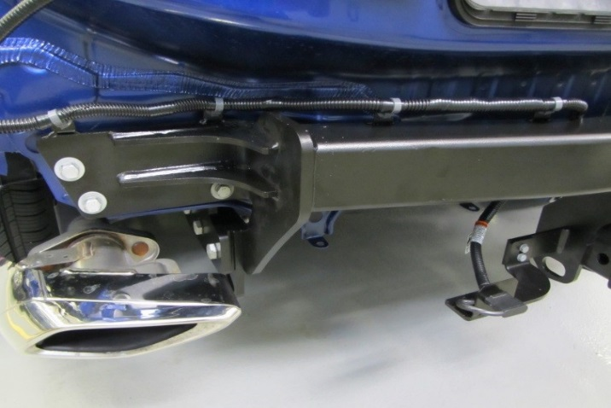
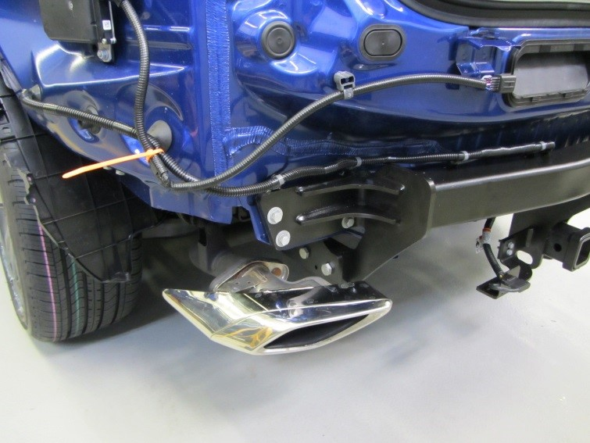
  - Secure the sub-wire to the hitch by inserting all four push mount clips to the tabs on top of the hitch (Fig. 4-3 and Fig. 4-4).
Fig. 4-4
Push mount clip
Fig. 4-3
60
  - Secure the trailer sub-wire harness to the vehicle wire harness with one wire tie (Fig. 4-3).
  - Insert the trailer connector (4-Flat) to the bracket mounted on the hitch support (Fig. 4-4).
  - Cut the excess of all wire ties used to secure the trailer wire harnesses.

Complete the Installation.
  - Reinstall the vehicle parts in reverse order of removal, including parts removed for the installation of the Towing Hitch (except the bumper under cover LH). Make note of the steps below.
  - If the vehicle is equipped with a strut tower brace, torque the two nuts to 20 N•m (15 lbf•ft) ( Fig. 5-1 and Fig. 5-2).
Fig. 5-1
12mm & 10mm sockets, ratchet & extension
Fig. 5-2
12mm & 10mm sockets, ratchet & extension

Torque: 20 N•m (15 lbf•ft)

  - Torque the floor anchor of the front seat outer belt assembly LH bolt to 42 N•m (31 lbf•ft) ( Fig. 5-3).
Fig. 5-3
14mm socket & ratchet

Torque: 42 N•m (31 lbf•ft)

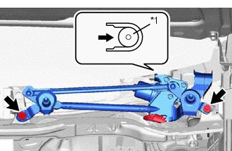
  - Torque the two windshield wiper motor and link assembly bolts to 5.5 N•m (49 lbf•in) ( Fig. 5-4).
Fig. 5-4
10mm socket, extension & torque wrench

Torque: 5.5 N•m (49 lbf•in)

  - Install the front fender to cowl side seal (LH and RH) (Fig. 5-5).
Fig. 5-5
LH shown
    - Clean the front fender to cowl side seal installation area on the body.
    - Apply double-sided tape to the front fender to cowl side seal.
    - Attach the five claws to install the front fender to cowl side seal ( Fig. 5-5).
  - Install the windshield wiper arm and blade assemblies.
    - Stop the windshield wiper motor assembly at the automatic stop position.
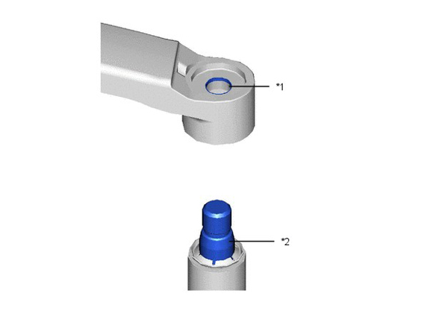
    - Clean the wiper arm serrations (*1 Fig. 5-6) to remove any burrs or dirt.
Fig. 5-6
NOTE: Do not grind down the wiper arm serrations.
    - Clean the wiper pivot serrations (*2 Fig. 5-6).

    - Install the front wiper arm and blade assemblies LH and RH into their original positions (Fig. 5-7 and 5-8).
Fig. 5-8
14mm socket, extension & torque wrench
Fig. 5-7
14mm socket, extension & torque wrench
    - Torque the nut of the wiper arm to 26 N•m (19 lbf•ft).

Torque: 26 N•m (19 lbf•ft)
HINT: Hold the wiper arm while tightening the nut.

  - Prepare the bumper under cover LH for reinstallation.
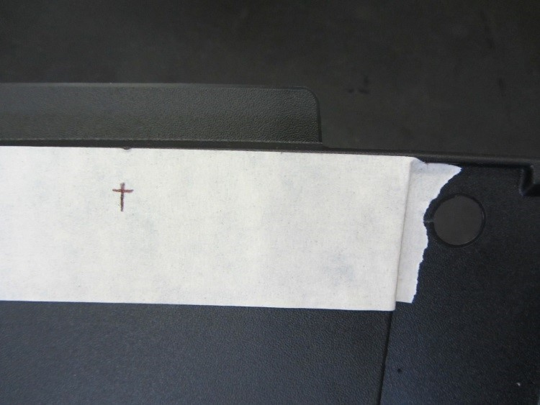
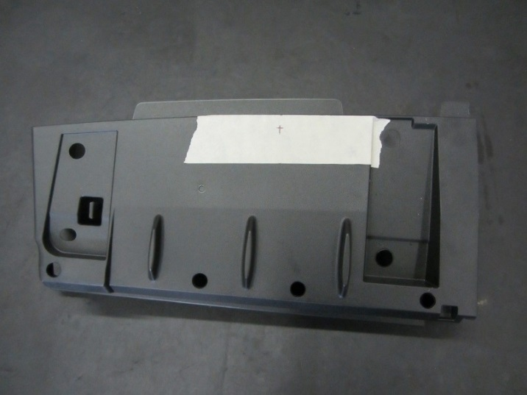
    - Use a 14 mm (9/16”) bit to drill the under cover LH in the position shown (Fig. 5-9 and Fig. 5-10).
Fig. 5-10
75 mm
10 mm
14 mm diameter
Drill & 14 mm (9/16”) bit
Fig. 5-9
HINT: Tape the tray with masking tape to mark the hole position and prevent scratches on the plastic tray.

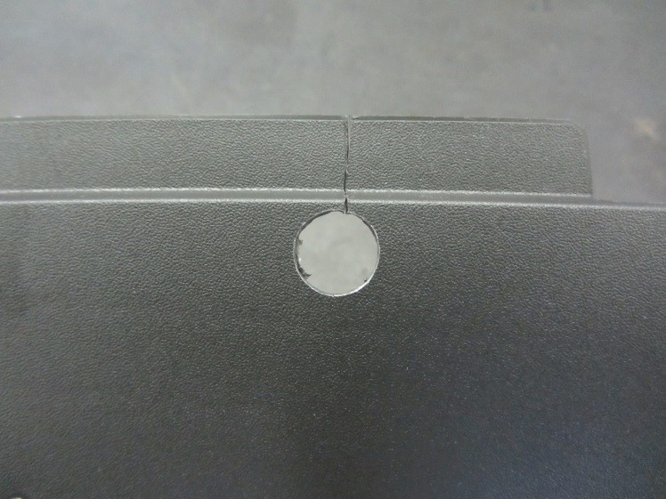
    - Cut the under cover from the drilled hole to the edge as indicated by the dotted line (Fig. 5-11).
Fig. 5-11
Metal saw

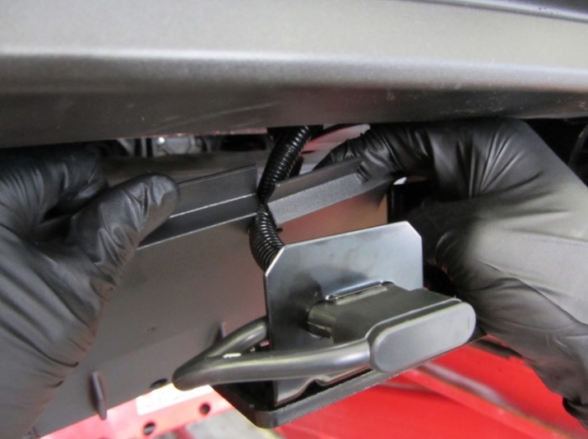
    - Pass the trailer sub-wire harness through the cut from the previous step and place the bumper under cover LH in position for reinstallation (Fig. 5-12).
Fig. 5-12

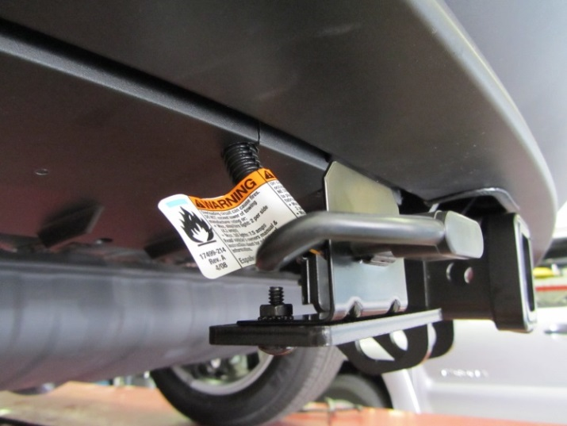
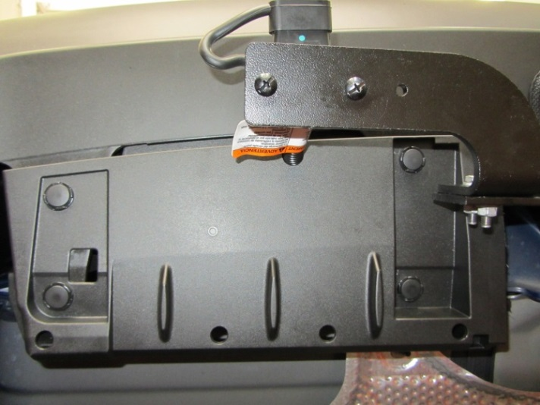
  - Reinstall the bumper under cover LH (Fig. 5-13 and Fig. 5-14).
Fig. 5-14
Fig. 5-13
  - Verify the trim panels fit together properly with no uneven gaps.

  - Reinstall the vehicle’s negative (-) battery terminal to the battery (Fig. 5-15) and install the DCC fuse if required.
Fig. 5-15
10mm socket & torque wrench

Torque: 5.4 N•m (48 lbf• in).

NOTE: Do not touch the positive terminal with any tool when installing the negative battery cable.

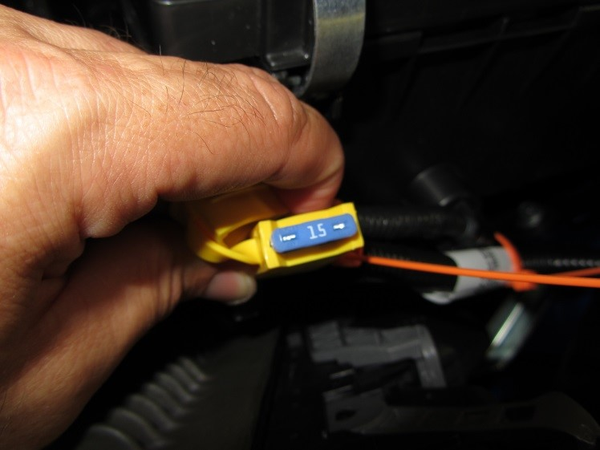
  - Reinstall the 15A fuse in fuse holder on the trailer power wire harness (Fig. 5-16).
Fig. 5-16
  - Place the installation instructions and fuse location card with the owner’s manual in the glove box.
  - Perform the functional checks for the trailer wire harness and the post-installation checks for the vehicle (see next page).
  - Overloading the circuit can cause a fire. DO NOT exceed the load of the towing manufacturer rating.
    - Maximum stop/turn light load: 2 bulbs per side (total 4.2 amps)
    - Maximum tail lights load: 7.5 amps

Accessory Function Checks
Right turn signal
Left turn signal
Brake
Tail light
Tail light & brake
Left turn & brake
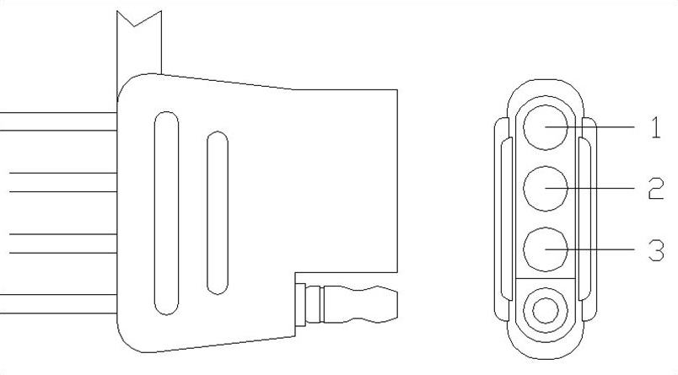
Right turn & brake

Vehicle Function Checks
Individual vehicle light functions

Trunk light
Warning lights
Front wipers & washers

Circuit 1 flashes
Circuit 2 flashes
Circuit 1 & 2 activate
Circuit 3 activates
Circuit 1, 2 & 3 activate
Circuit 1 activates & 2 flashes
Circuit 1 flashes & 2 activates

Verify that the corresponding vehicle lights activate. If light does not activate then check the connection.
Functions normally
No warning lights illuminated in the combination meter
Operate the front wiper while spraying washer fluid onto the windshield glass. Make sure that the front wiper functions properly and the wiper does not come into contact with the vehicle body.
Lift each front wiper blade twice after the front wipers stop and check the wiper set position.

Vehicle Appearance Check
After accessory installation and removal of protective cover(s), perform a visual inspection.

Failure Mode
- No power to the trailer light functions

- Corrosion on the 4-flat plug

Ensure no damage (including scuffs and scratches) was caused during the installation process.
(For PPO installations, refer to TMS Accessory Quality Shipping Standard.)

Troubleshooting Steps
- Check the trailer wiring harness fuse per the owner’s manual fuse location card.
- Check the 4-flat connection between the trailer and the vehicle to ensure the connection is fully engaged.
- Turn all functions off and remove the key for 10 seconds and retest the functions with the trailer attached.
- Turn all functions off and remove the key for 10 seconds with the trailer disengaged. Use a multi-meter to check the function output at the 4-flat. If all functions work, check the trailer for a potential short or overload described in the owner’s manual fuse location card.

- Clean the connection and add Dielectric Grease (sold separately) to the terminal pins.

